**George Herbert Walker School of Business & Technology**

# Department of Computer & Information Sciences

# CSDA 6010 Data Analytics Practicum



# Case Studies:

* Maximizing Profits from Software Sales
* Empowering Used Mobile-Device Buyer
* Mortgage Payback Behavior Analytics

**May 2024**

**Saint Louis, Missouri**

Department Chair: Dr. James Curtis

Instructors:

Dr. Jiangping Wang   
Dr. Ali Ovlia

**CSDA 6010 Data Analytics Practicum**

**Nikroshitha A Notani**

**Webster University**

**Spring 2024**

# 

# Project -1 Maximizing Profits from Software Sales

Table of Contents

1 Introduction 6

2 Business Opportunity 6

3 Business Goal 6

4 Dataset Preprocessing 7

4.1 Attributes Description 7

5 Data Preprocessing 8

5.1 Check for missing values 8

5.2 Check for Zero 8

6 Data Analysis 9

6.1 Categorical Variables: 9

6.1.1 Histograms 9

6.1.2 Sources 9

6.1.3 Relation between Web.Order and Purchase 10

6.2 Numerical Variables 11

6.2.1 Histograms 11

6.2.2 Spending 12

6.2.3 Freq 12

6.2.4 Days difference 12

6.3 Multivariate Analysis 12

6.3.1 Relationship between two outcome variables (Purchase and Spending) 12

7 Feature Selection Methods 13

7.1 Predictor Analysis and relevancy 13

7.2 Dimension Reduction 14

8 Business consideration 14

9 Data Transformation 15

10 Data partitioning methods 15

10.1 Train, Validation and Test sets 15

11 Model Selection for Goal-1 17

11.1 Model-1: Logistic Regression 17

11.1.1 Modeling and performance 17

11.1.2 Applying Stepwise to the Model 18

11.1.3 Rebuilding of the Model with selected predictors 18

11.2 Model Evaluation Using Alternative Approaches: Classification Tree and KNN 19

11.3 Selected Model for Goal-1 21

11.4 Model Performance on Holdout Data with Logistic regression. 21

12 Model Selection for Goal-2 22

12.1 Model-1: Linear Regression Model 22

12.1.1 Model Evaluation and Performance 22

12.1.2 Stepwise Performed on linear regression 22

12.1.3 Rebuilding of Model Using Selected Predictors 22

12.2 Model Evaluation Using Alternative Approaches: Regression Tree 23

12.3 Model Comparison and Performance Evaluation: 24

12.4 Implication of Selected Model 24

13 Profit Analysis 25

13.1 Gross Profit Estimation 25

13.2 Adding of Columns to Data Frame According to Business requirement 25

13.3 Gain Chart 26

14 Business Recommendation 27

15 Conclusion 27

16 Executive Summary 27

# Introduction

North point is a software list firm. It’s prepared to launch a collection of games and educational software through mailing. As a part of its strategy, it wanted to grow its customers base, therefore it joined a consortium of listing firms that matches their background.

A pool was created where each firm supplied their customers and had an opportunity to pick the same number of customers randomly supplied by them to the pool for the mailing experiment. It conducted a test by drawing 20000 names and did a test mailing. This test yielded a response rate of 5.3% ie 1065 customers only purchased.

# Business Opportunity

The business goal for North-Point, the software list firm, is to maximize profitability and expand its customer base through targeted marketing efforts. This involves effectively identifying potential purchasers from a pool of prospects and optimizing marketing strategies to increase the likelihood of conversions.

By leveraging predictive modeling and data analysis techniques, North-Point aims to enhance its mailing campaigns' effectiveness, ultimately driving higher sales and revenue. Additionally, the company seeks to minimize mailing costs while maximizing returns, ensuring efficient resource allocation and sustainable business growth.

Overall, the business goal is to achieve a balance between cost-effectiveness and revenue generation, positioning North-Point for long-term success in the competitive software market.

# Business Goal

North-Point aims to enhance the effectiveness of its mailing campaign by leveraging machine learning models. The first model will classify prospects as purchasers or non-purchasers based on attributes such as acquisition source, purchase frequency, and update history.

The second model will predict the spending number of potential purchasers. By targeting high-probability prospects and estimating their potential spending, North-Point expects to increase response rates, optimize revenue, reduce costs, and strengthen customer engagement through personalized marketing strategies tailored to individual preferences and behaviors.

# Dataset Preprocessing

**Description of the Dataset**

The dataset comprises of information on 2000 customers. 1000 are purchasers and 1000 are non-purchases. It is a balanced dataset. There are two outcome variables in this dataset i.e. purchase and spending. The purchase variable indicates the response achieved by the test mail and their purchase behavior. The spending variable indicates the amount spent during the purchase.

## Attributes Description

**sequence number:** It is a unique identifier for each record in the dataset.

**Us:** It is a binary indicator which specifies whether the person resides in the United States.

**Source_a, source_c, source_b, source_d, source_e, source_m, source_o, source_h, source_r, source_s, source_t, source_u, source_p, source_x, source_w:** They indicate the channels or sources through which the customers were gained. Each source represents a firm present in the consortium. As it a binary indicator 1 denotes the source of customer and the 0 indicate that they are not dummy number

**Freq:** It represents the frequent count of purchases made by the customer. This numeric variable can help analyze transactional behavior and overall engagement with the business.

**last_update_days_ago:** It represents the number of days that have passed since the last update was made. It can be valuable for understanding customer engagement patterns and making informed decisions.

**1st_update_days_ago:** It represents the number of days that have passed since the first update. Understanding the duration from the first interaction can be valuable for analyzing customer retention, loyalty, and behavior over time.

**Web_order:** The attribute is a binary indicator that likely denotes whether a purchase was made through web or not. 1 indicates purchase was made online and 0 indicates that purchase was made through a channel or an offline method.

**gender = male:** It is a binary indicator. 1 indicates that the customer is male and 0 indicates another gender depending on the context.

**Address is res:** It is a binary indicator. If the value is 1 it indicates the customer address is a residential and if the value is 0 it indicates either commercial or non-residential. This attribute allows business to differential between residential and nonresidential.

**Purchase:** It is a binary indicator. If the value denotes 1 then that customer responded to the test mailing and made a purchase and if the value denotes 0 then the customer hasn’t made their purchase through web. It is a crucial indicator for understanding the customer’s behavior in response to specific initiatives.

**Spending:** It is a numeric variable that represents the amount spent by customers who made a purchase. Purchase is made either by web or offline method. This attribute indicates revenue generated and the overall financial impact of marketing efforts.

# Data Preprocessing

## Check for missing values

There are no missing values in the dataset. However, have checked the 0 values for every attribute.

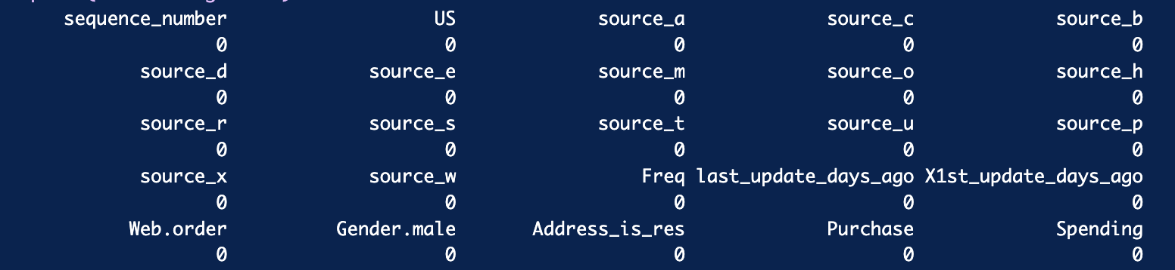

Figure 1 Checking for missing value.

## Check for Zero

Calculating the count of zero values for relevant numeric variables as the dataset has both numeric and binary variables. I have checked for a condition stating how many entries in the dataset have a non-zero value in the 'Purchase' column while indicating zero spending. It then counts and prints the number 0 and states that there are no 0 columns present in the dataset.



Figure 2 Checking for Zero

# Data Analysis

We have employed various types of charts to extract insights from the data, aiming to enhance the analysis process for subsequent steps in model development.

## Categorical Variables:

### Histograms

It visually represents the frequency distribution of categorical variables. This could help us understand variable relationships and feature importance.

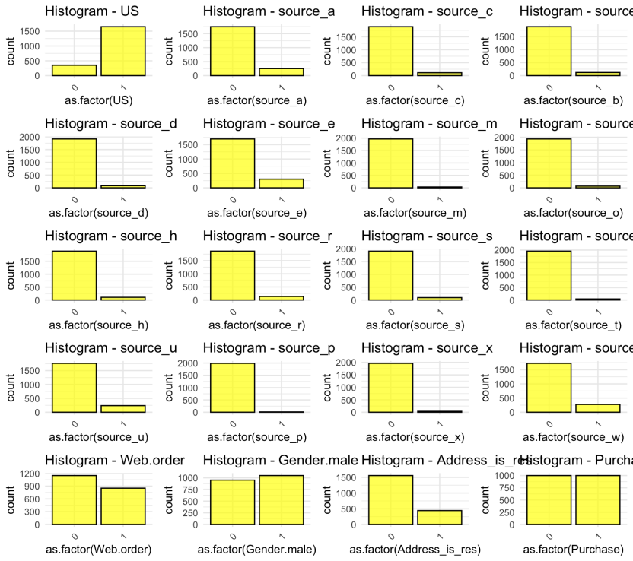

Figure 3 Histogram for all sources.

The visual representation allows us to discern which attributes exhibit a higher frequency of the value '1,' indicating their significance in predicting the outcome variable. By identifying attributes with a predominant occurrence of '1,' we can infer their importance in influencing the predictive outcome.

### Sources

I built histogram on all the sources defined ( Source_a, Source_c, Source_b, Source_d, Source_e, Source_m, Source_o, Source_h, Source_r, Source_s, Source_t, Source_u, Source_w) and checked that from which source did the highest number of purchases were made. ie its from source e and w



Figure 4 Count of occurrences of 1 for each source column.

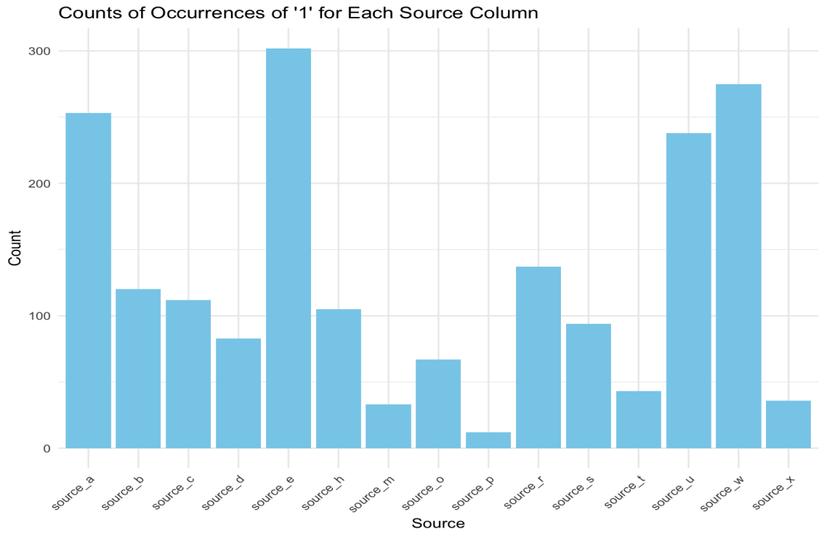

Figure 5 Visualization of different sources.

### Relation between Web.Order and Purchase

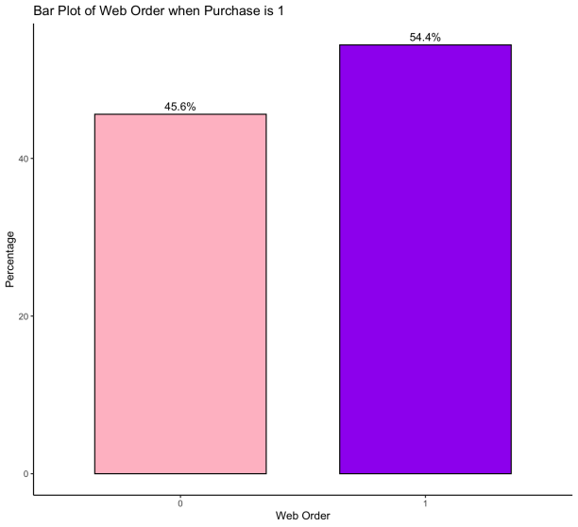

Figure 6 Percentage of purchases made through different modes.

The visual representation suggests that the web order category exhibits a greater frequency, indicating a relatively larger share of purchases made through this channel.

## Numerical Variables

### Histograms

Histogram are used for numeric variables and in our dataset we have four numeric variable ie (freq , last_update_days_ago , 1st_update_days_ago , Spending)

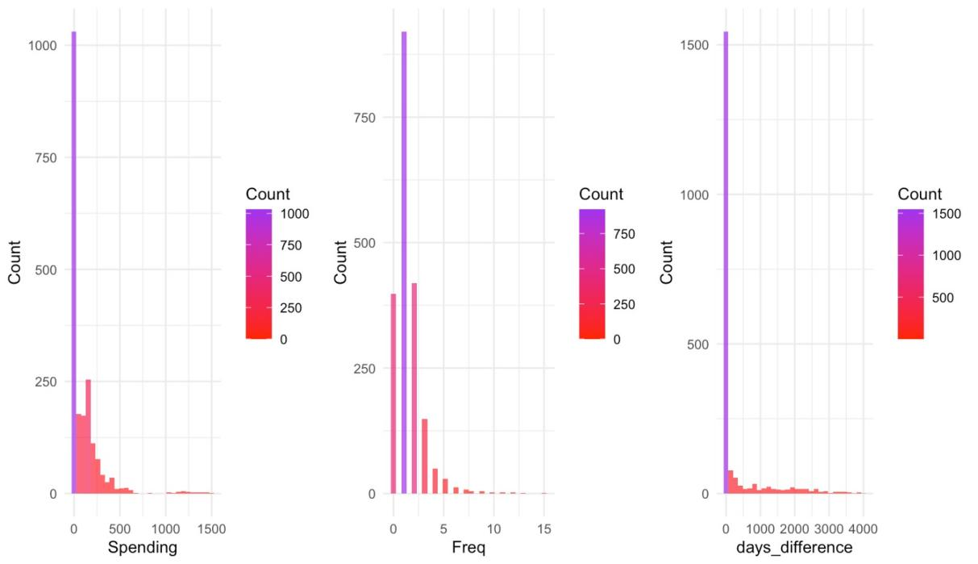

Figure 7 Histogram with 2000 observation.

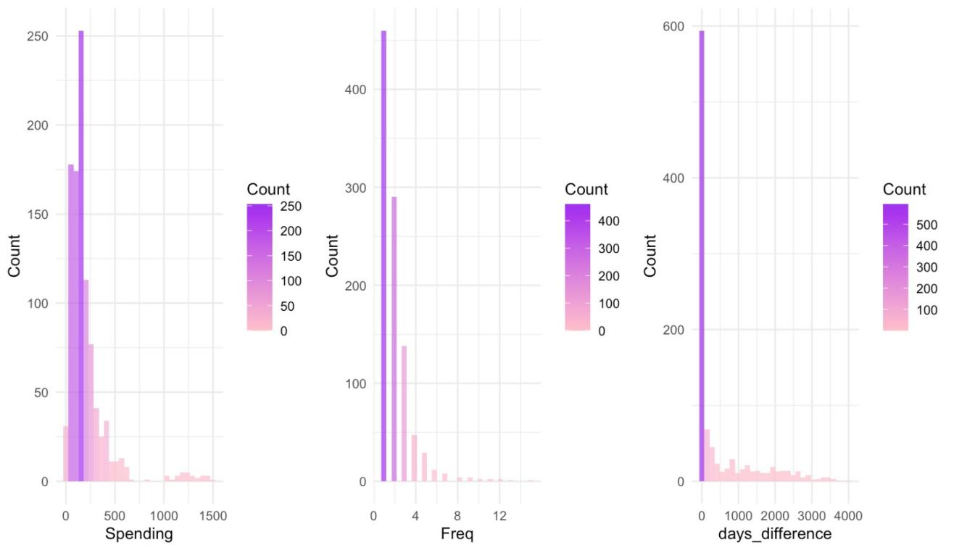

Figure 8 Histogram with only purchaser’s data.

### Spending

Here we can see that the maximum amount spent by the customer falls under 1$ - 600$ and the number of customers is less for those who have spent more than 1000$.

### Freq

Here the customers who have brought only once have the highest count compared with the customers who have purchased more than 5 times.

### Days difference

This shows the difference are days between the first update and last update of customer interaction and the count is higher for customer who interacted only once.

## Multivariate Analysis

### Relationship between two outcome variables (Purchase and Spending)

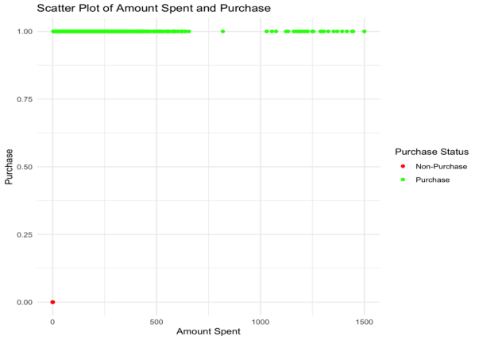

Figure 9 Relationship of purchasers and spending.

The correlation coefficient of 0.5495676 suggests a positive correlation between the "Spending" and "Purchase" variables. Upon visual inspection, it becomes apparent that, when the purchase is equal to 1, customers tend to exhibit higher spending amounts, typically falling within the range of 1$ to 600$.

# Feature Selection Methods

## Predictor Analysis and relevancy

The logistic regression model was constructed to predict crucial variables against the outcome variables, a stepwise backward AIC selection process was conducted.

This procedure aimed to refine the model by iteratively removing variables that did not significantly contribute to its predictive power. The results of this stepwise analysis revealed the importance of certain features, which are outlined below.

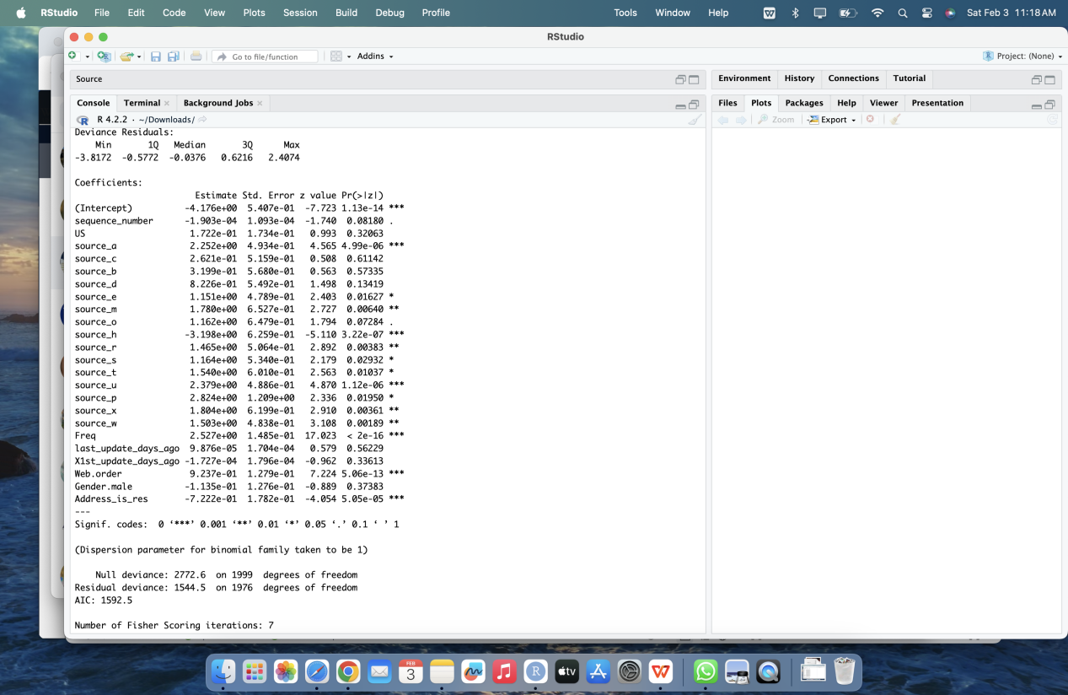

Figure 10 Feature Importance Using Linear Model

Upon visual analysis of the logistic regression model, it becomes evident that specific sources ('source_a,' 'source_m,' 'source_u'), purchase frequency ('Freq'), web orders ('Web.order'), and residential address ('Address_is_res') significantly influence the likelihood of a purchase. Through multiple iterations using AIC backward elimination, the model has been refined to identify optimal coefficients for predicting purchase behavior.

To further enhance model performance, exploration of various possibilities regarding predictor selection and treatment is warranted. This could involve experimenting with different subsets of predictors, considering interactions between variables, exploring polynomial transformations, or incorporating additional relevant features.

## Dimension Reduction

Dimension reduction refers to situations in which some variables in a dataset are highly correlated or provide redundant information. In other words, certain variables may convey similar information, rendering them redundant for analysis.

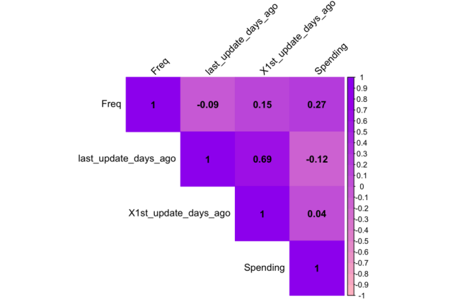

Figure 11 Correlation Matrix of Numerical Variables

Due to the high correlation observed between 'last_update_days_ago' and 'X1st_update_days_ago,' it is hypothesized that both variables offer similar information. To address redundancy, the recommendation is to remove the 'X1st_update_days_ago' attribute from the numeric variables in the dataset. This simplification aims to enhance model interpretability and reduce multicollinearity. It is predicted that each categorical attribute in the dataset is independent and can collectively contribute to model building by predicting essential aspects. However, it is believed that attributes such as "US," "Address is res," and "sequence_number" exhibit minimal dependencies on the outcomes of "Purchase" and "Spending”. Therefore, for further analysis and model simplification, it is reasonable to consider removing these attributes. This decision assumes that these variables may not significantly contribute to predicting the outcomes of interest. However, thorough analysis and modeling techniques are necessary to verify these conclusions.

# Business consideration

In the realm of cost-effectiveness, North-Point must meticulously assess the expenses entailed in executing machine learning-driven targeted mailings. This encompasses an in-depth analysis of printing, postage, and associated mailing costs juxtaposed against the anticipated returns from the remaining 180,000 observations. Crucially, ensuring that the projected revenue from these mailings surpasses the incurred costs stands as a pivotal determinant in maximizing profitability. Customer segmentation, facilitated by machine learning models, emerges as a pivotal strategy for North-Point to tailor its marketing endeavors adeptly.

# Data Transformation

1. Removed the 'sequence number' column from the dataset.
2. Renamed certain columns to match the specified convention:

a 'Gender.male' was renamed to 'Gender is male'.

b 'Web.order' was renamed to 'Web_order'.

c 'Last_update_days_ago' was renamed to 'Last_Interaction'.

d 'X1st_Update_days_ago' was renamed to 'First_Interaction'.

e 'Spending' was renamed to 'Amount_Spent'.

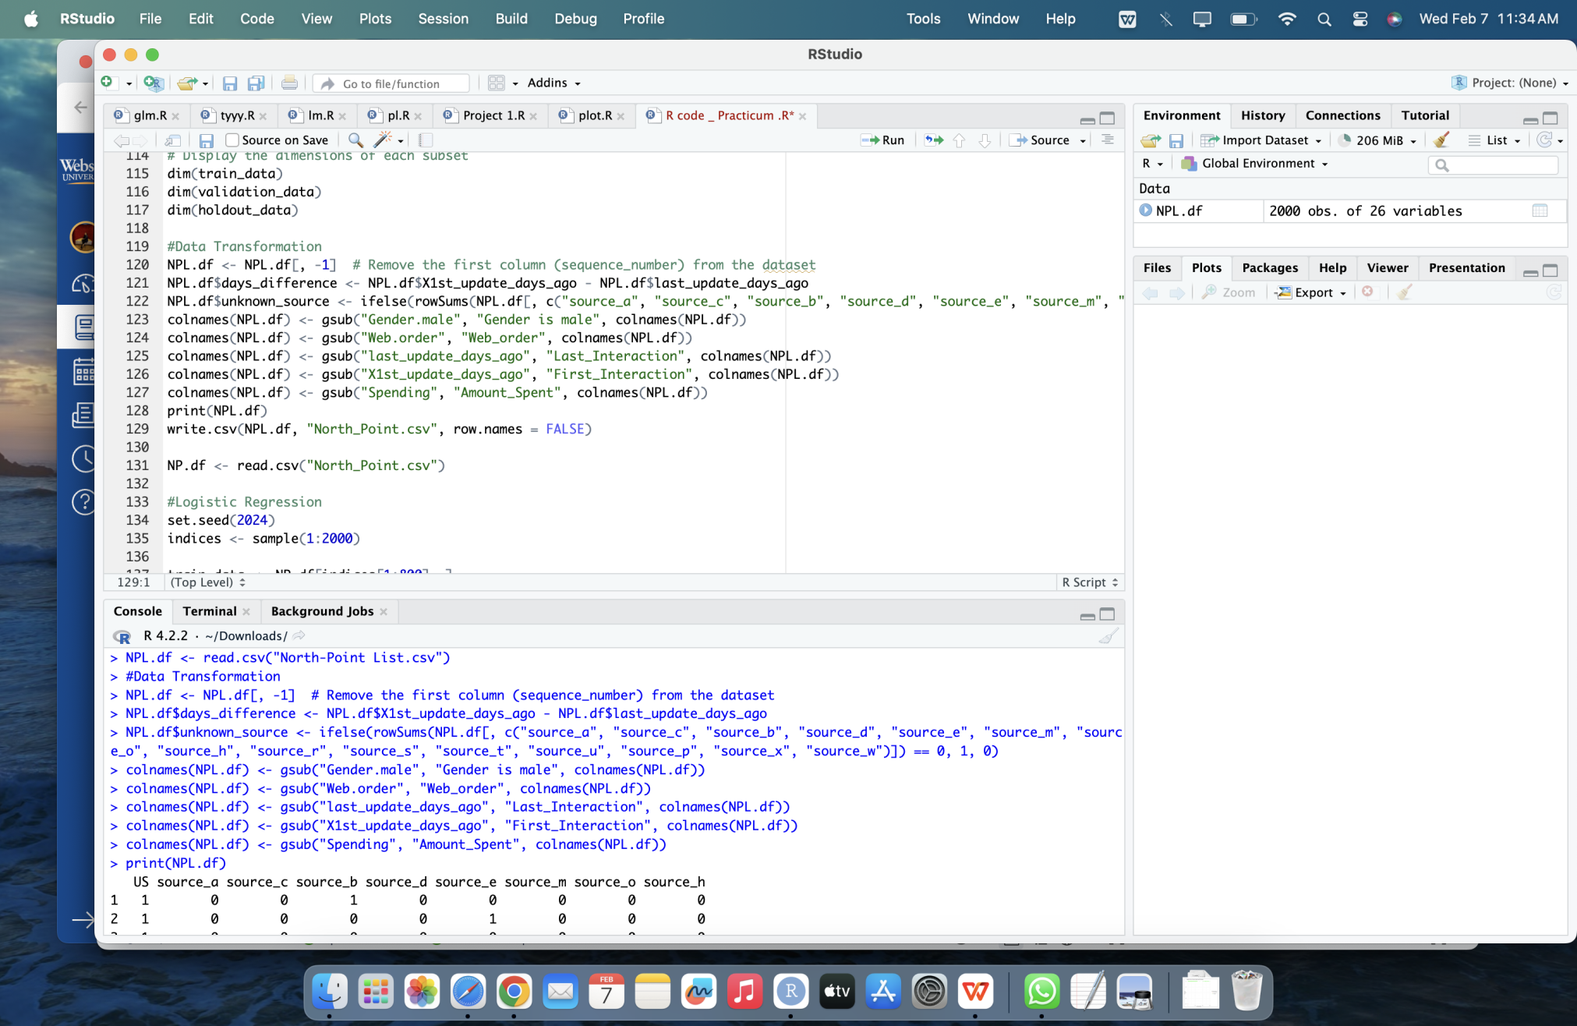

Figure 12 Data Transformation

# Data partitioning methods

Data partitioning methods are useful as they allow for the separation of data into distinct subsets, such as training and testing sets, facilitating model development, validation, and evaluation while ensuring unbiased performance assessment and enhancing the generalization ability of machine learning models.

## Train, Validation and Test sets

For the random indices partitioning method, the data is divided by shuffling the indices randomly. Subsequently, subsets are selected for training, validation, and test sets based on these shuffled indices.

In this case, 1400 records are allocated for training, 300 records for validation, and 300 records for testing. This straightforward approach allows for the division of the data into distinct subsets without considering the distribution of the outcome variable. Although the user expressed an interest in checking models for a 70:15:15 ratio, they have decided to adhere to method 2, aligning with the specified business requirements.

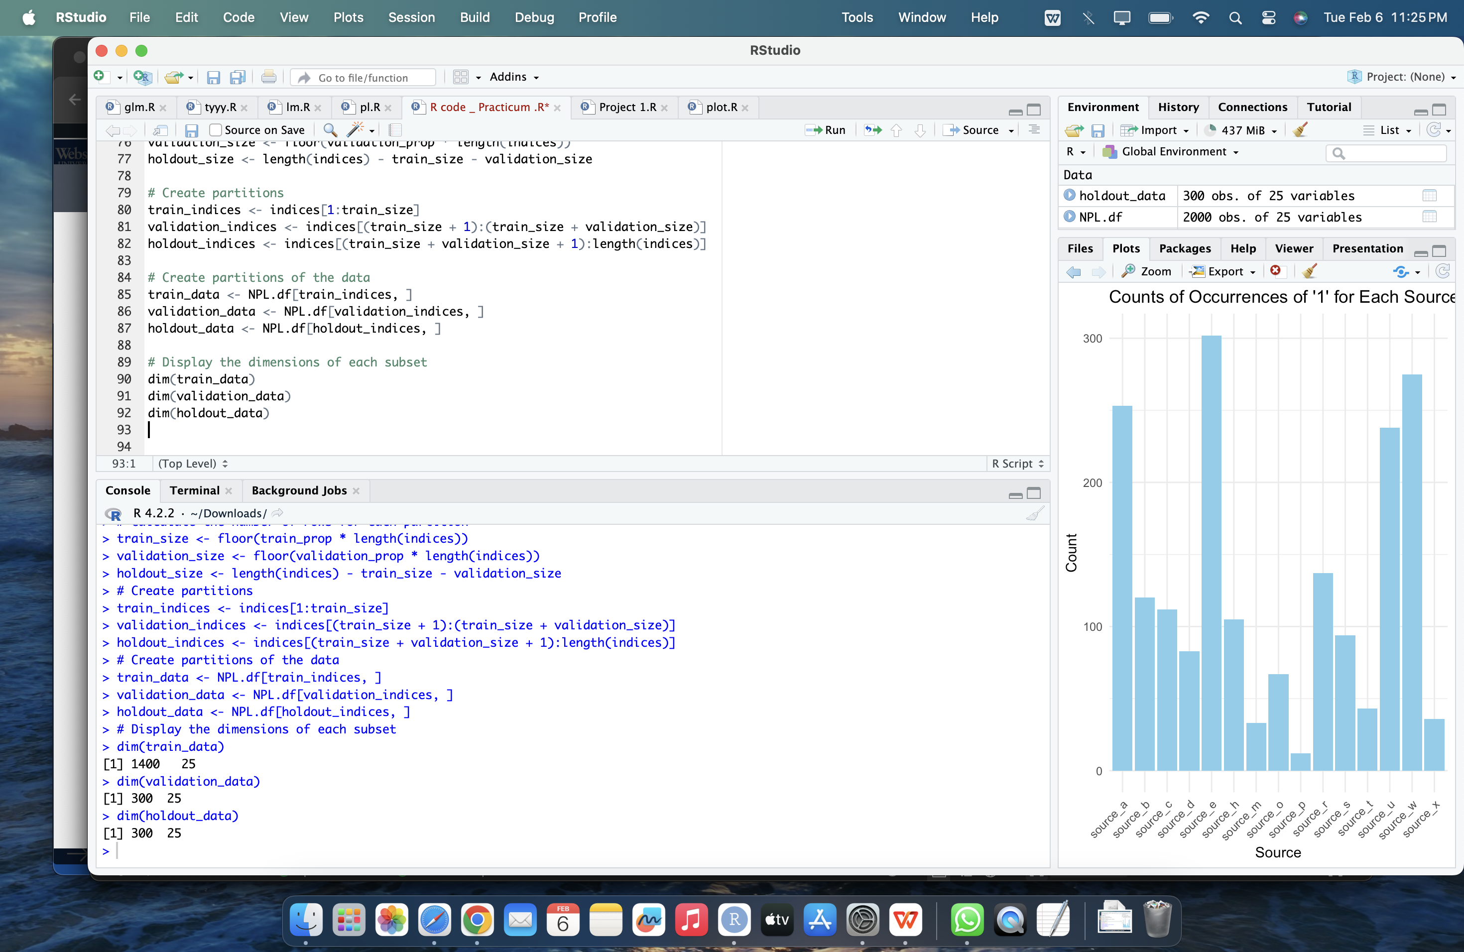

Figure 13 Method 1 Data Partitioning

**Method 2: Train and Test sets**

In contrast to Method 1, Method 2 employs the createDataPartition() function from the caret package. This function samples the data in such a way that it replicates the distribution of the outcome variable across the partitions. This ensures that the balance of the outcome variable is maintained across the training, validation, and test sets. Method 2 is especially advantageous when dealing with datasets characterized by class imbalances or when preserving the distribution of the outcome variable is crucial for effective model training and evaluation.

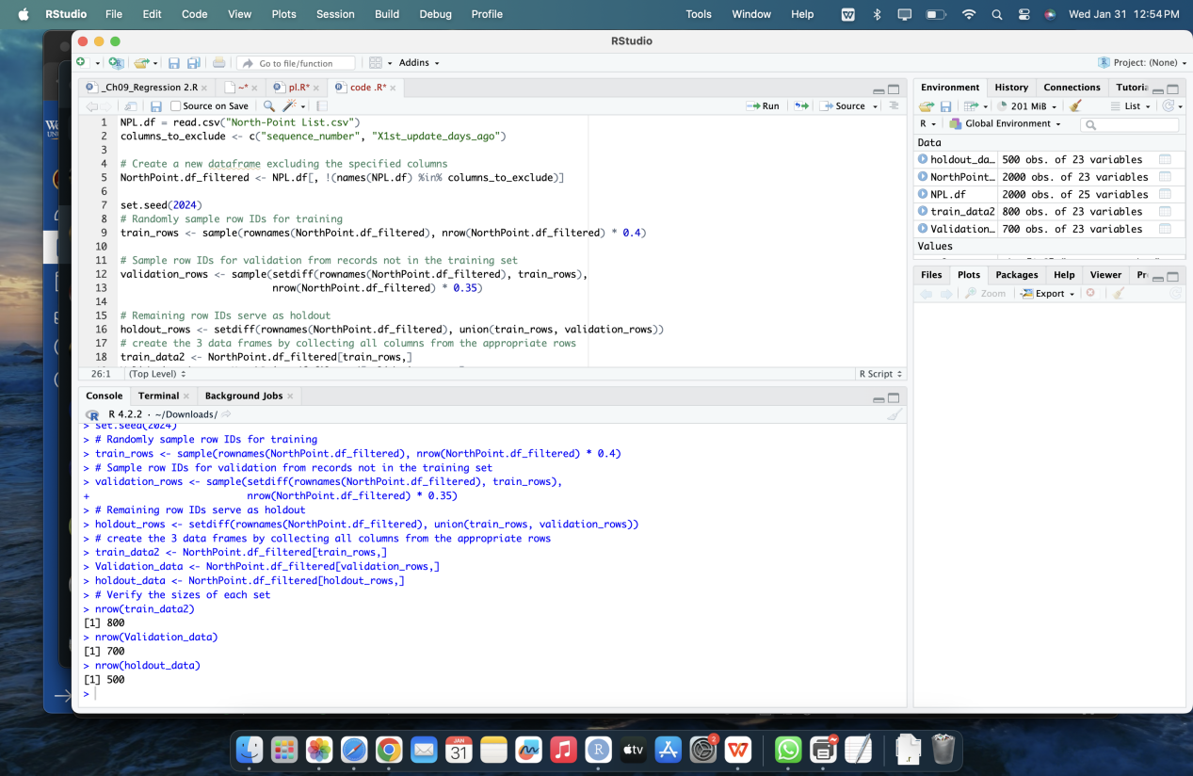

Figure 14 Method 2 Data Partitioning

These two methods offer distinct approaches to data partitioning, each with its own set of advantages and considerations. Method 1 adopts a straightforward and random partitioning strategy, which can be quick and easy to implement. On the other hand, Method 2 provides a more controlled approach using the createDataPartition() function from the caret package. This method ensures that the distribution of the outcome variable is preserved across partitions, aligning with the specified business requirement. While Method 1 may be suitable for basic analysis tasks, Method 2 is preferred in situations where maintaining the balance of the outcome variable across partitions is crucial for accurate model training and evaluation.

# Model Selection for Goal-1

## Model-1: Logistic Regression

**Goal:** To classify customers as purchasers or non-purchasers with the target attribute being Purchase

### Modeling and performance

As per the specified business requirements, logistic regression has been chosen as the first model for achieving the goal. Logistic regression will be utilized to develop a predictive model aimed at classifying customers as either purchasers or non-purchasers based on the provided dataset. This model will leverage various attributes such as source channels and interaction history to make predictions regarding customer behavior.

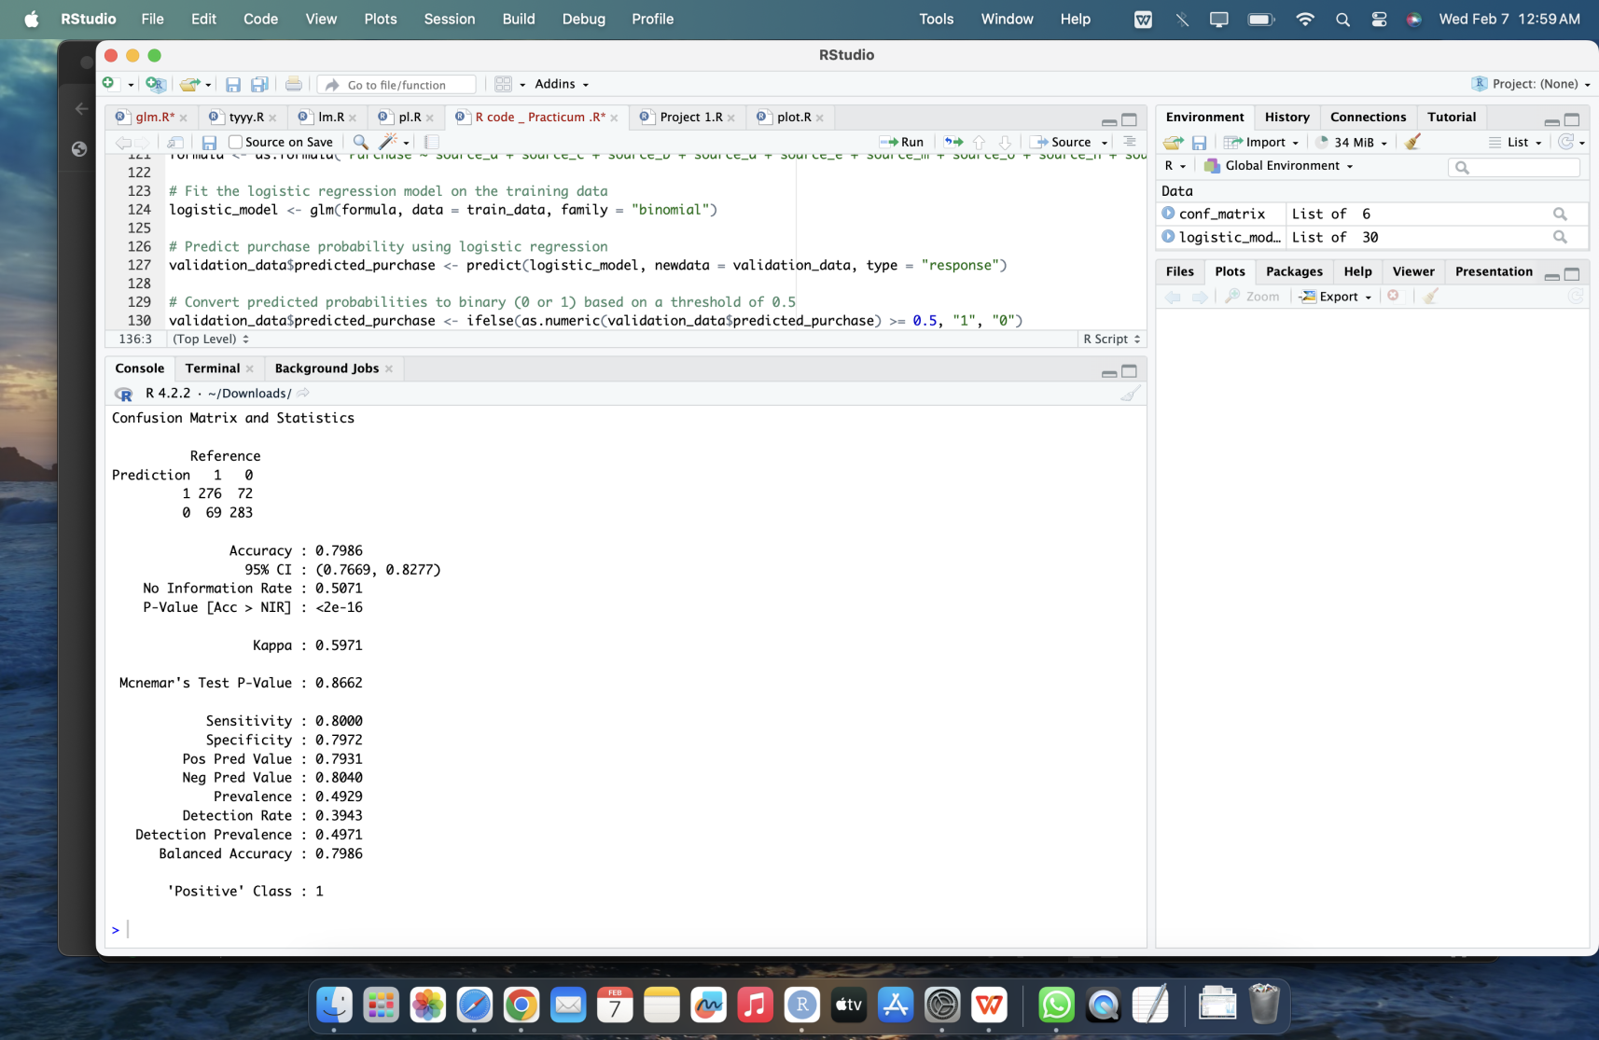

Figure 15 Logistic Regression using all Predictors.

The confusion matrix provides an overview of the logistic regression model's performance in binary classification. It reveals 276 true positives (correctly predicted purchasers) and 283 true negatives (correctly predicted non-purchasers). However, the model also produced 72 false positives (incorrectly predicted purchasers) and 69 false negatives (incorrectly predicted non-purchasers).

Overall, the model achieved an accuracy of 79.86%, indicating the proportion of correctly classified instances out of the total predictions. Furthermore, the sensitivity (true positive rate) and specificity (true negative rate) of the model stand at 80.00% and 79.72%, respectively. The positive predictive value, which signifies the proportion of actual purchasers among the instances predicted as purchasers, is calculated at 79.31%.

### Applying Stepwise to the Model

By applying stepwise selection with the Akaike Information Criterion (AIC) for backward elimination, the logistic regression model has identified the most significant predictors for the target variable Purchase. This methodology systematically removes predictors that do not substantially contribute to the model's predictive capability, as determined by the AIC criteria.

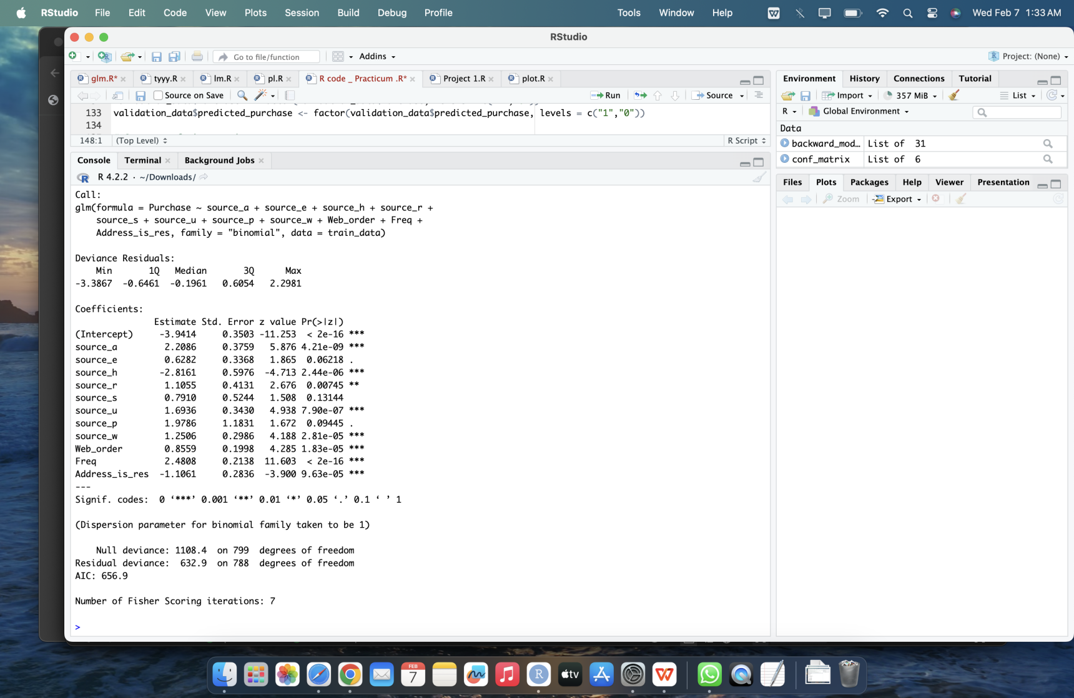

Figure 16 Stepwise applied to predict important predictors.

The important predictors identified for the logistic regression model are as follows: "Purchase ~ source_a + source_h + source_r + source_u + source_w + Web_order + Freq + Address_is_res". These predictors have been determined to be significant in predicting the target variable, which is the likelihood of a customer making a purchase.

### Rebuilding of the Model with selected predictors

Subsequently, the model was rebuilt using only these important predictors. Upon reevaluation, it was observed that the accuracy of the model slightly decreased, indicating a small reduction in the proportion of correctly classified instances. However, there was a notable improvement in sensitivity, suggesting that the model now performs better at correctly identifying positive cases, i.e., instances where customers make a purchase. This improvement in sensitivity signifies an enhancement in the model's ability to capture true positive cases, which is a favorable outcome despite the slight reduction in overall accuracy.

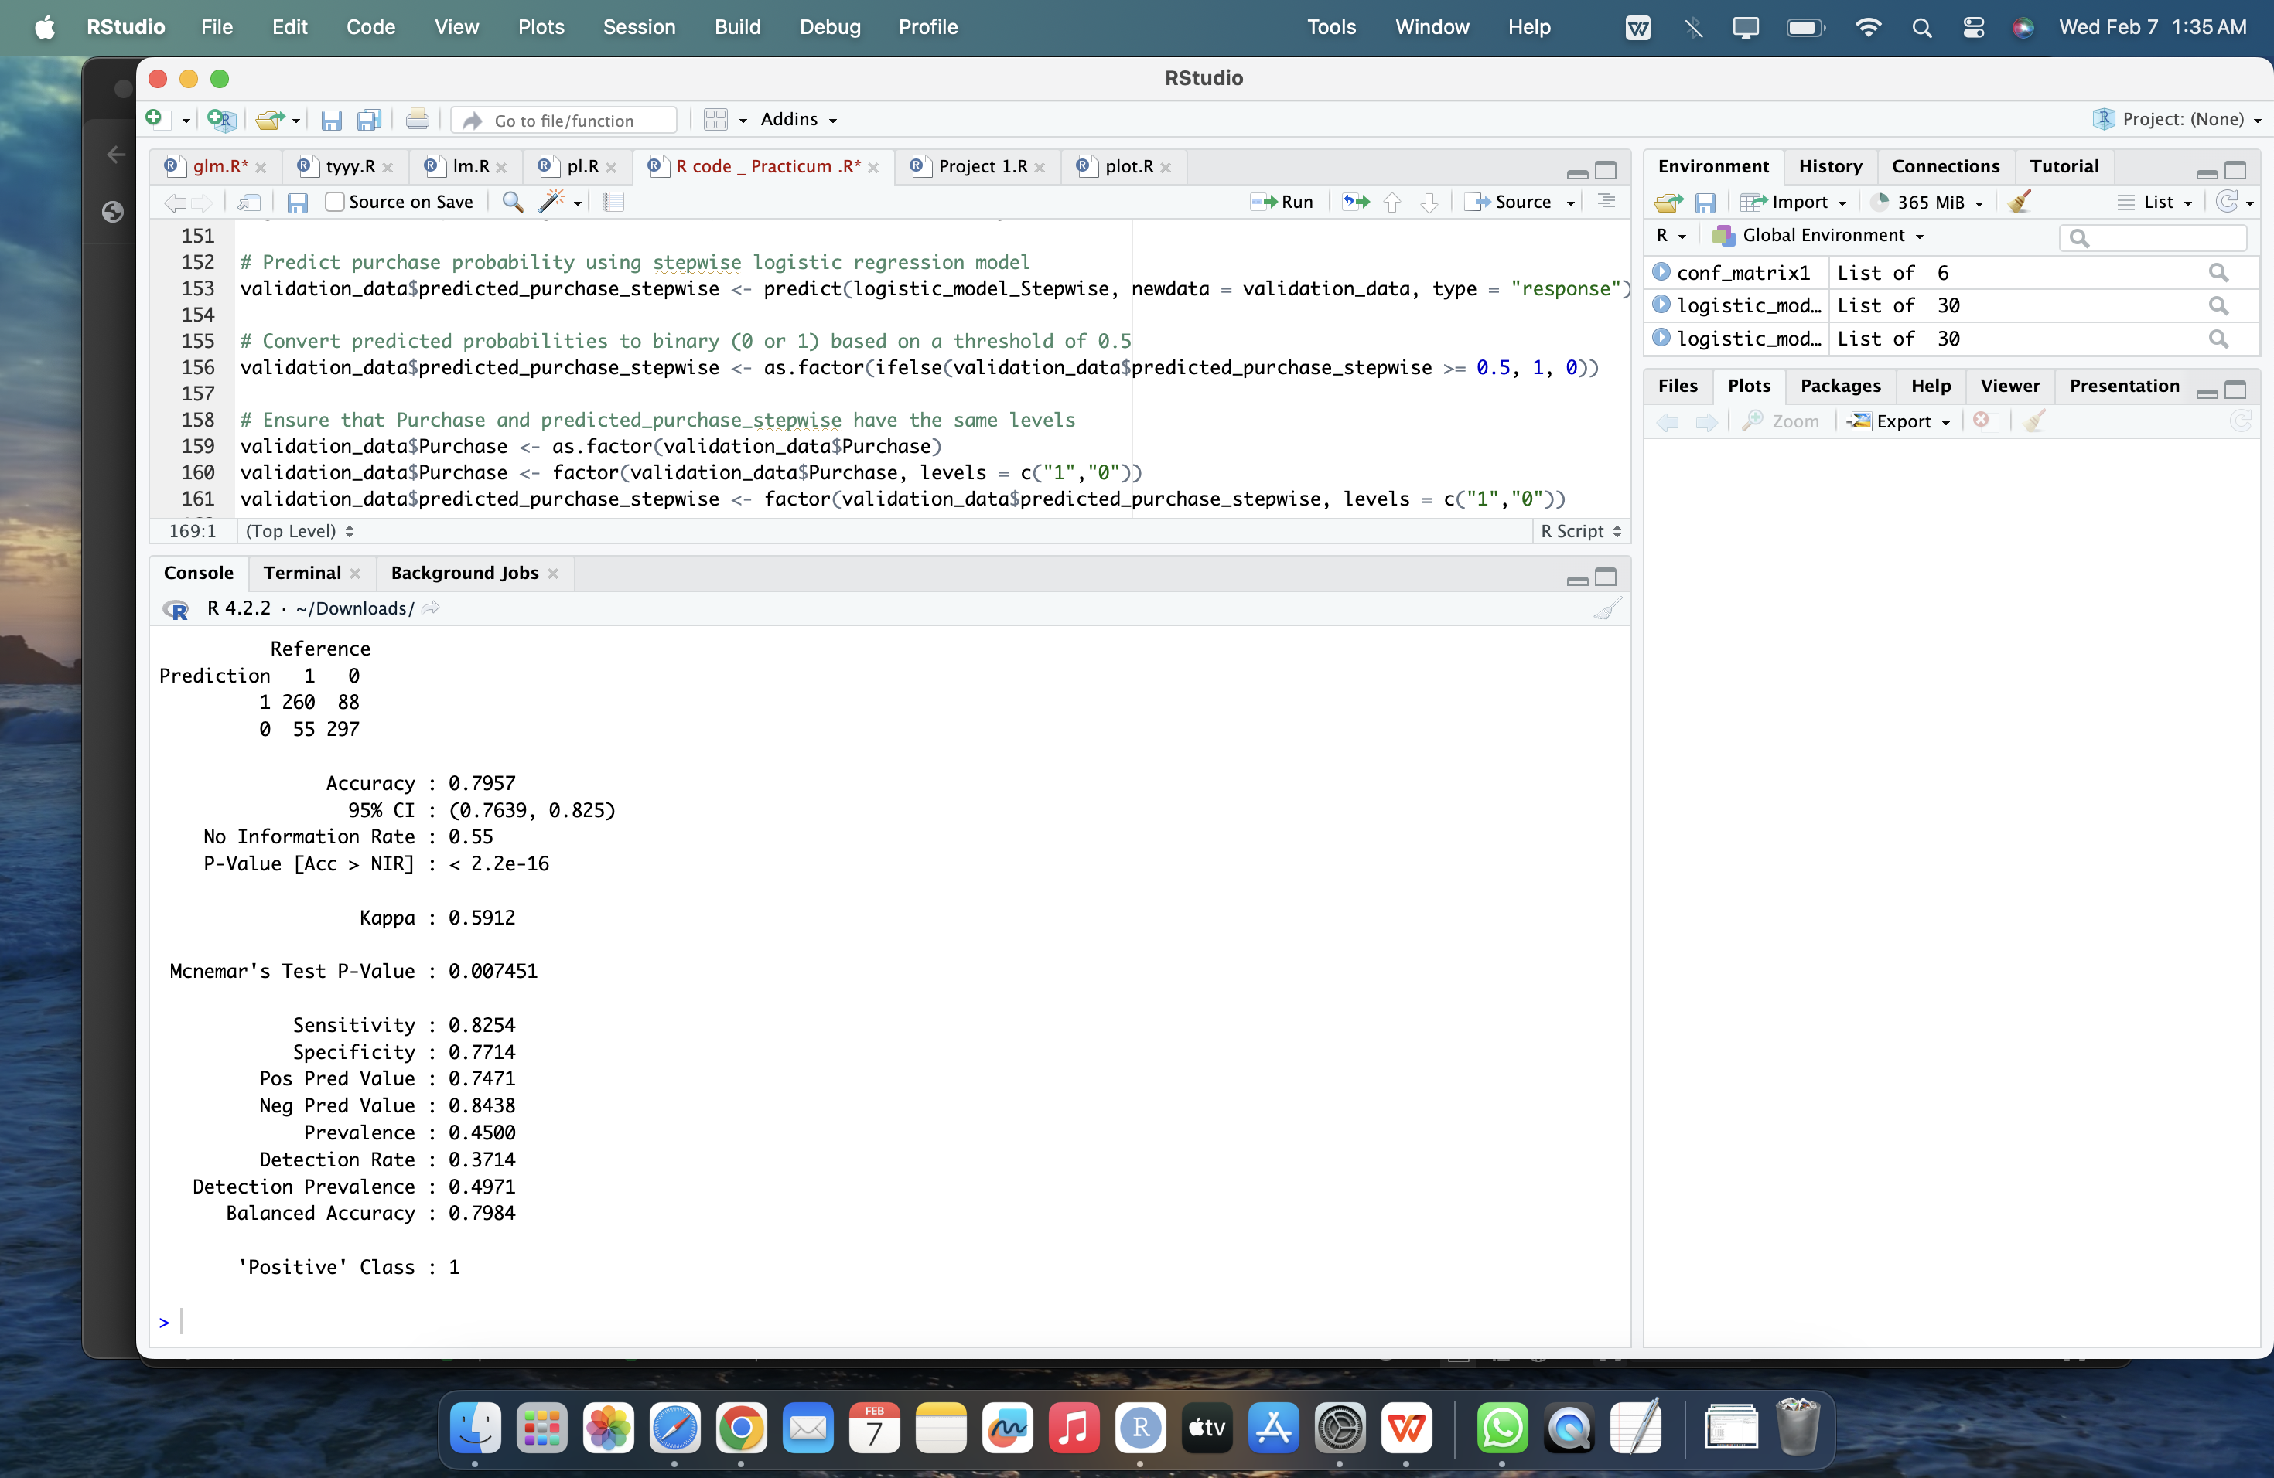

Figure 17 Model Performance with important Predictors.

## Model Evaluation Using Alternative Approaches: Classification Tree and KNN

Following the identification of important predictors through backward stepwise selection, the next step was to evaluate model performance using alternative approaches such as classification tree and KNN. This analysis aimed to ascertain whether either of these models surpassed the performance of the logistic regression model, aligning with the stipulated business requirements. Here is the classification tree obtained using the rpart algorithm after constructing the model with the significant predictors.

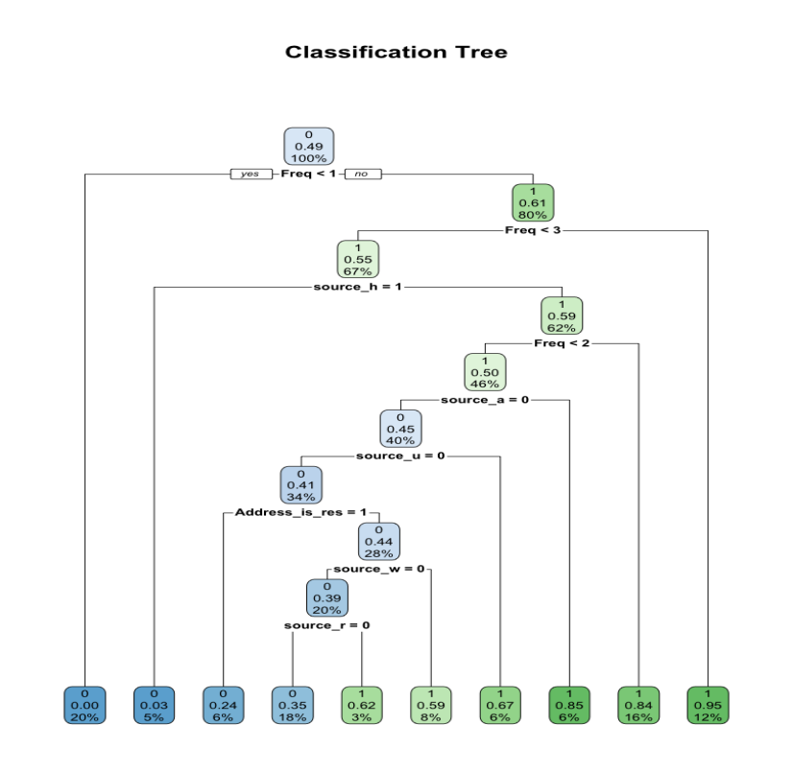

Figure 18 Classification tree using rpart with selected predictor through backward AIC.

**Model Comparison and Performance Evaluation**

|  |  |  |  |
| --- | --- | --- | --- |
|  | Logistic Regression | Classification Tree | KNN Model |
|  | Screenshot 2024-02-07 at 1.35.55 AM | Screenshot 2024-02-07 at 1.54.41 AM | Screenshot 2024-02-07 at 1.29.18 PM |
| Accuracy | 0.7957 | 0.7829 | 0.7729 |
| Sensitivity | 0.8254 | 0.7722 | 0.7838 |

## Selected Model for Goal-1

Based on the evaluation results, logistic regression emerges as the most suitable model for achieving Goal 1. With superior performance compared to the classification tree and KNN models, logistic regression exhibits higher accuracy and sensitivity. Consequently, it aligns with the business requirement of accurately classifying instances and identifying positive cases, making it the recommended choice for fulfilling Goal 1 and addressing the underlying business needs.

## Model Performance on Holdout Data with Logistic regression.

Below is the confusion matrix reflecting the test accuracy of the logistic regression model, which was chosen as the preferred model for Goal 1 due to its superior performance.

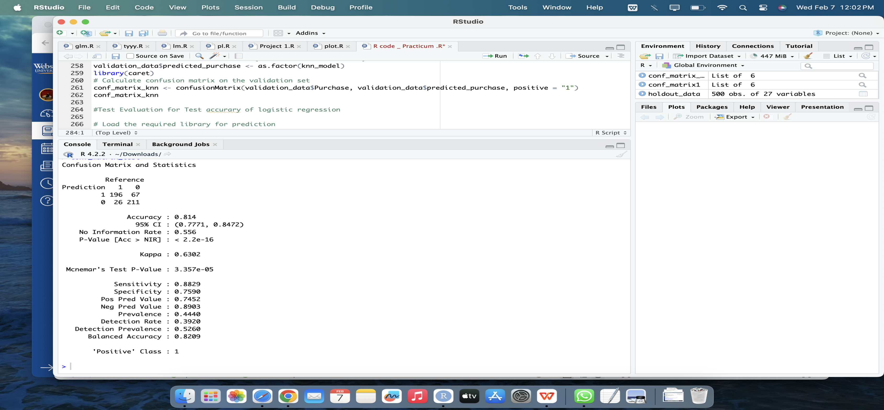

Figure 19 Confusion matrix of Holdout data of the model.

The test accuracy of the model is 81.4%, indicating that it correctly classifies approximately 81.4% of instances in the dataset. With a sensitivity of 88.29% and specificity of 75.90%, the model demonstrates its ability to effectively identify true positive cases while also accurately recognizing true negative cases. Overall, the balanced accuracy of 82.09% underscores the model's capability to provide a balanced and accurate classification performance across both positive and negative classes, making it a robust choice for business consideration for Goal 1.

# Model Selection for Goal-2

## Model-1: Linear Regression Model

**Goal:** To predict the spending amount for customers identified as purchasers. Considering the target attribute is Spending.

### Model Evaluation and Performance

After initially selecting Linear Regression as the primary model and fitting it with spending as the outcome variable, the Mean Absolute Error (MAE) was computed as 118.85.

### Stepwise Performed on linear regression

Subsequently, a stepwise selection procedure was employed to identify the most significant predictors for the spending outcome. Now, the model is being reconstructed incorporating these important predictors to reassess its performance.

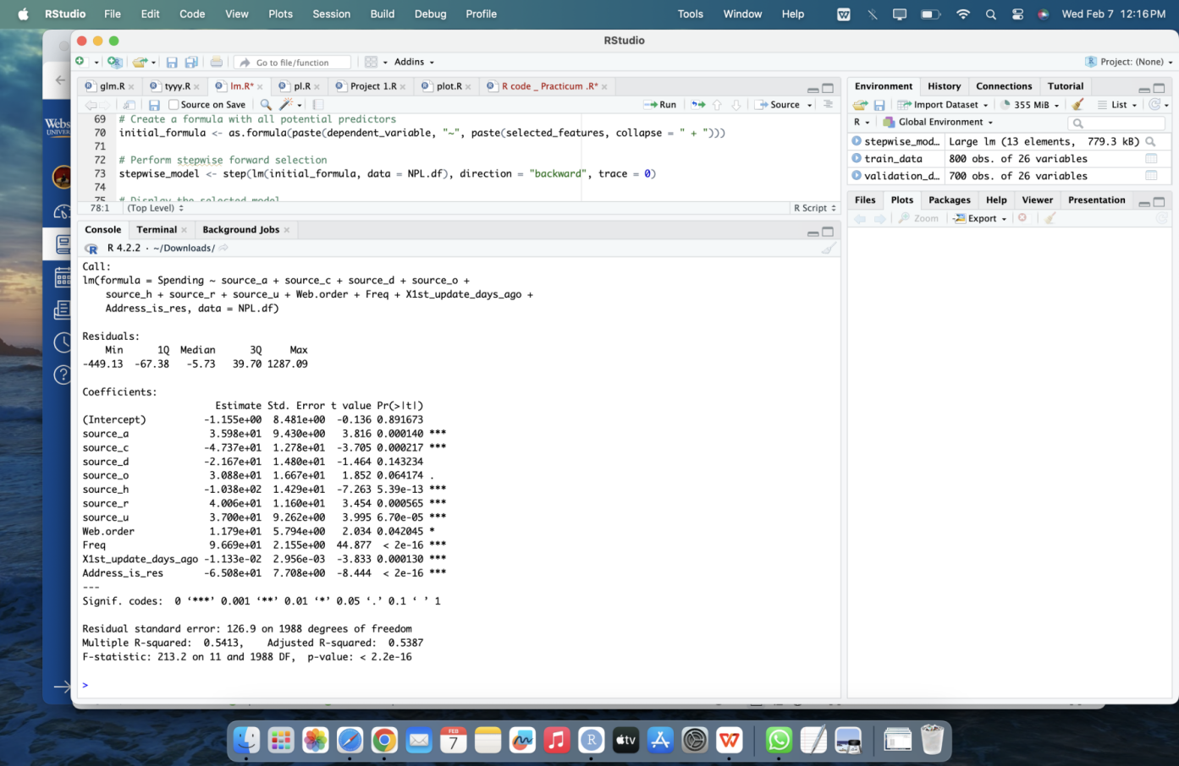

Figure 20 Linear Regression Model

### Rebuilding of Model Using Selected Predictors

By incorporating these important predictors, we rebuild the Linear regression Model.

Since the Mean Absolute Error (MAE) performs better when using selected predictors compared to using all predictors, we shall proceed with utilizing only these selected predictors for further analysis for Goal 2. This streamlined approach will simplify the model while retaining predictive accuracy, allowing for more efficient analysis and interpretation of results.

## Model Evaluation Using Alternative Approaches: Regression Tree

**Regression Tree**

A regression tree model was built using the `rpart` function in R, employing "anova" as the splitting method.

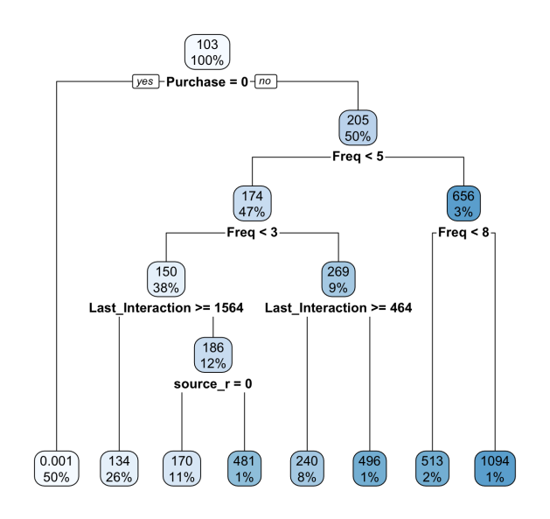

Figure 21 Regression Tree with selected predictors obtained during stepwise.

The model was then visualized to aid interpretation. Predictions for `Amount_Spent` were generated on the holdout dataset, and the Mean Absolute Error (MAE) was calculated to evaluate the model's predictive accuracy, yielding a MAE value 76.404.

## Model Comparison and Performance Evaluation:

|  |  |
| --- | --- |
| **Model** | **MAE** |
| Linear Regression | 114.35 |
| Regression Tree | 99.212 |

In comparing linear regression and regression tree models for estimating `Amount_Spent`, the regression tree model demonstrated lower Mean Absolute Error (MAE), suggesting better predictive accuracy. However, despite this superior performance, the decision to retain linear regression was based on it interpret-ability, ease of implementation, and alignment with business objectives.

While the regression tree model offered theoretical advantages, including improved accuracy, practical considerations favored linear regression's transparency and compatibility with existing business processes. Therefore, despite the regression tree's superior performance, linear regression was deemed the most suitable choice for meeting our business needs and objectives.

## Implication of Selected Model

**Performing MAE evaluation for Holdout Data with selected predictors for linear regression**

Given that the business requirement is best suited to linear regression analysis, we have utilized this model as our primary choice. After training the linear regression model on the training data, we proceed to evaluate its performance on the holdout dataset, which serves as an independent validation set.

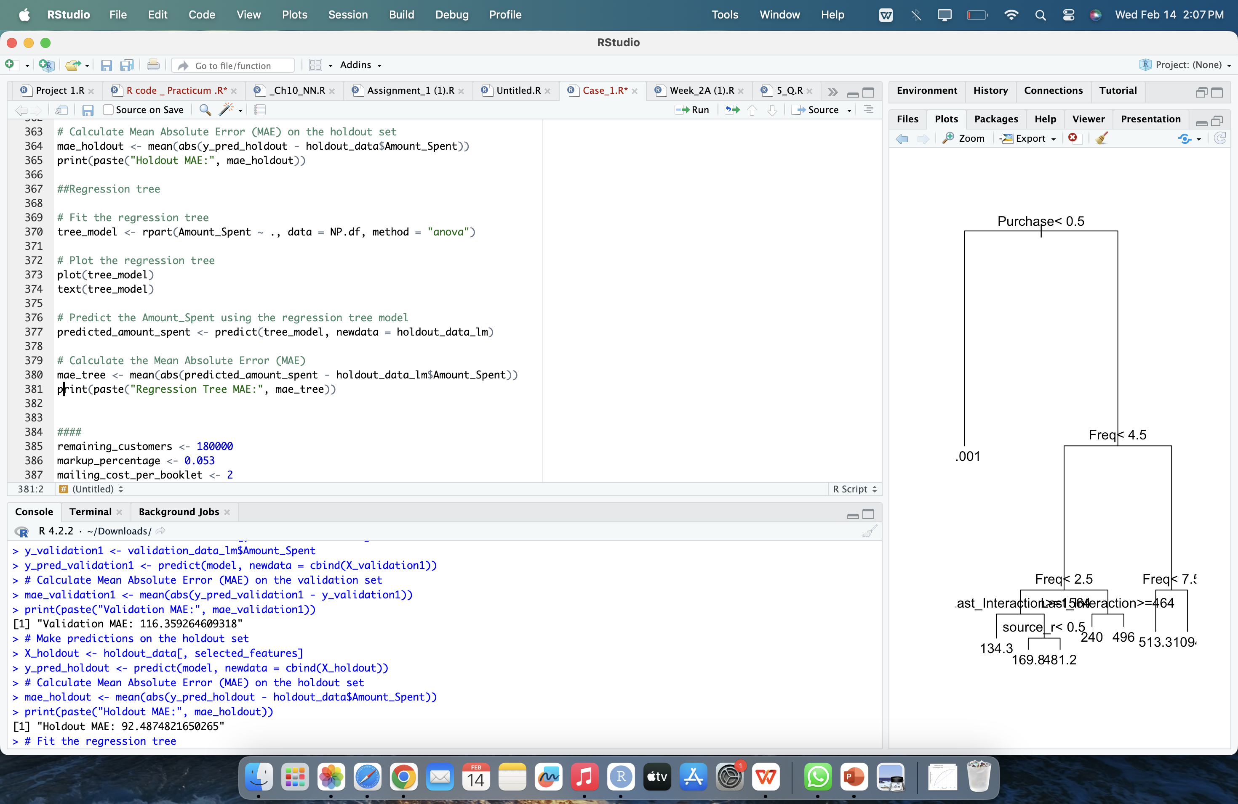

Figure 22 MAE of Holdout Data for Linear Regression Model

Having selected the model as the optimal choice for predicting Goal 2, it was applied to a holdout data set for validation. By utilizing the selected features, predictions were made on the holdout set, resulting in a Mean Absolute Error (MAE) of 92.48. This MAE value quantifies the average absolute difference between predicted and actual spending amounts in the holdout data set, serving as a measure of the model's predictive accuracy on unseen data. With a lower MAE indicating better predictive performance, this result suggests that the model generalizes well to new data, reaffirming its effectiveness in predicting spending amounts for Goal 2.

# Profit Analysis

## Gross Profit Estimation

The code snippet begins by extracting the amount spent by purchasers from the dataset and filtering out any non-numeric values. Subsequently, the mean spending per purchase is computed. The gross profit is then calculated by estimating the number of remaining customers (180,000), multiplying it by the difference between 5.3% of the mean spending per purchase and the mailing cost per booklet ($2). This provides an approximation of the potential gross profit the firm could expect from the remaining customer base if selections were made randomly.

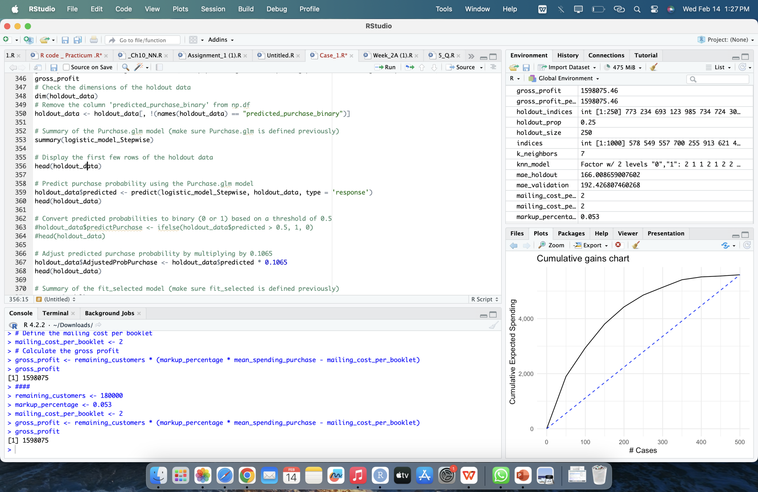

Figure 23 Gross Profit

The Estimated gross profit is 1598075.

## Adding of Columns to Data Frame According to Business requirement

After adding the specified columns to the original validation data frame as described. The resulting data frame would have the following added columns. Each column would contain the respective predicted or adjusted values:

* Column with predicted spending from the selected machine learning model.
* Column with predicted spending values from the work in step 3-b.
* Column for adjusted probability of purchase.
* Column for expected spending, adjusted as in step 1.

This enhanced data frame would provide comprehensive insights for further analysis, incorporating both predicted spending values and adjusted probabilities, facilitating a better understanding of customer behavior and potential revenue expectations. This is used to build the gain chart.

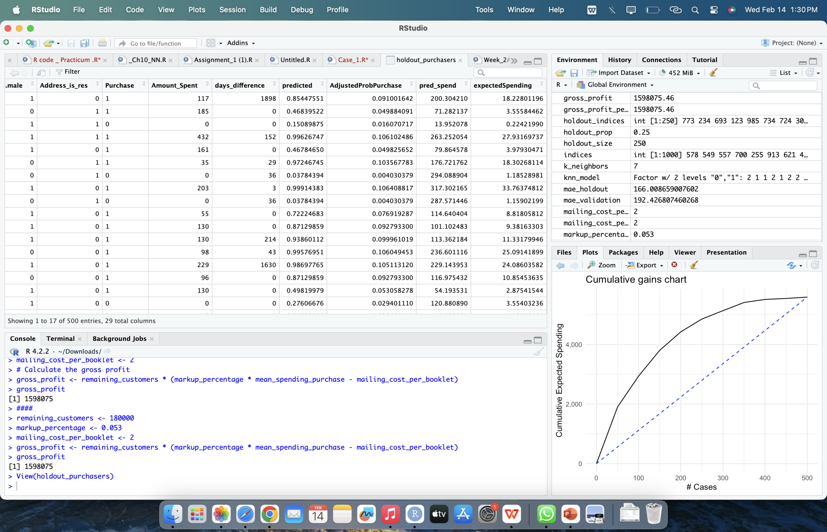

Figure 24 Expected Spending

## Gain Chart

The gain chart visually represents cumulative expected spending captured by a predictive model, with x-axis indicating observation ranks by predictions and y-axis showing cumulative spending. At around 500 observations, approximately 80% of total expected spending is reached, highlighting the model's effectiveness.

Notably, focusing on the top 350 targets by the model yields substantial spending, nearing the curve's peak, suggesting their profitability. The dashed baseline indicates cumulative expected spending without the model's predictions.

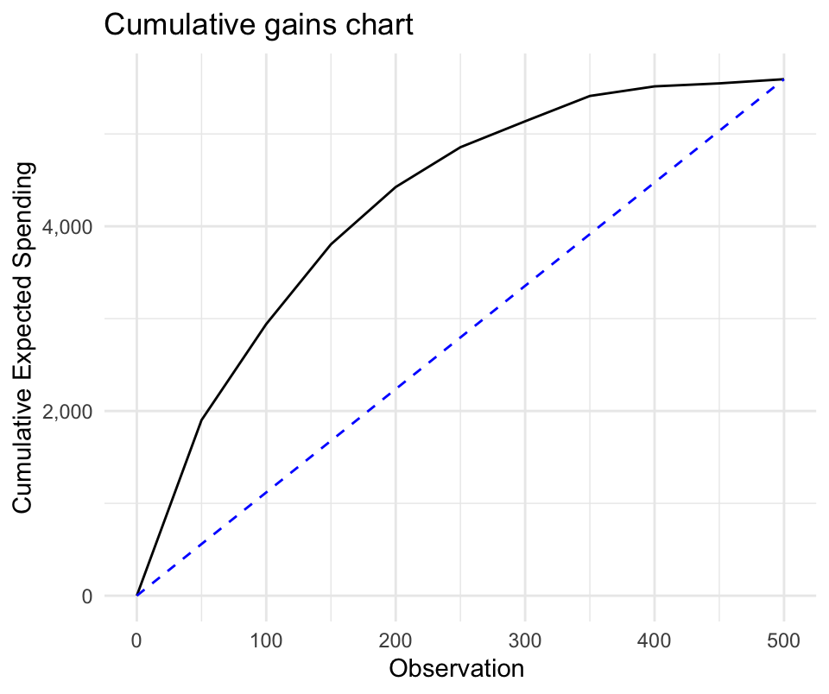

Figure 25 Gain Chart

# Business Recommendation

Based on the comprehensive analysis conducted, North-Point is advised to implement targeted marketing efforts leveraging predictive models such as logistic regression and linear regression. By tailoring marketing campaigns towards high-probability prospects and segments with the highest potential spending, North-Point can maximize ROI and optimize revenue generation.

It is crucial to continuously evaluate and refine mailing campaigns, conduct cost-benefit analyses, enhance customer engagement, invest in data quality and analytics, and monitor performance metrics. Through these strategies, North-Point can enhance its marketing effectiveness, optimize resource allocation, and drive sustainable business growth in the competitive software market.

# Conclusion

# Executive Summary

Nikroshitha A Notani

May 8, 2024

**Business Opportunities**

North-Point, a software list firm, faces the challenge of maximizing profitability and expanding its customer base through targeted marketing efforts, amidst the complexities of a competitive software market and a diverse dataset comprising 2000 customers with varying purchase behaviors and spending patterns.

**Solution**

Leveraging predictive modeling techniques such as logistic regression and linear regression, North-Point can accurately classify potential purchasers and predict their spending behavior. By tailoring marketing campaigns to high-probability prospects and segments with the highest potential spending, North-Point can optimize resource allocation, drive revenue generation, and achieve sustained success in the competitive software market.

Continuous evaluation and refinement of marketing campaigns, coupled with strategic investment in data quality and analytics, enable North-Point to adapt to evolving market dynamics and drive sustainable business growth. Through these proactive measures, North-Point solidifies its position as an industry leader, optimizing marketing effectiveness and maximizing ROI in the competitive software market.

**Project -2 Empowering Used Mobile-Device Buyer**

Table of Contents

1 Introduction 31

2 Business and Analytic Goal 31

3 Data Preprocessing 32

3.1 Dataset Description 32

3.2 Data types of each attribute 32

3.3 Attributes Definition 32

4 Data Exploration 34

4.1 Check for Missing Values 34

4.2 Check for Zero Values 35

5 Analysis for Numerical Variables 36

5.1 Box-plot for Numerical Variables with Outliers 36

5.2 Release Year vs Battery 37

5.3 Screen_Size Vs Device_Type 37

5.4 Distribution of days_used 38

5.5 Factors Affecting Device Weight 38

5.6 Distribution of Release Days by Year 40

5.7 Normalized_used_price Vs Normalized_new_price 41

5.8 Analysis Summary for Numerical Attributes 41

6 Analysis for Categorical Variables 42

6.1 Frequency Distribution of Device Brands - Histogram 42

6.2 Percentage of 4G and 5G availability for Others Brand Devices Histogram 43

6.3 Distribution Of OS Types 43

6.4 Distribution of Connectivity Type 44

6.5 Analysis Summary for Categorical Variables 44

6.6 Analysis with Target Variable 44

6.7 Box plot of categorical variables against Outcome 45

7 Predictor Analysis 46

8 Data Transformation 48

8.1 Dimension Reduction 48

9 Data Partitioning 49

10 Models Selection for Goal-1 49

10.1 Model 1: Stepwise Regression 50

10.1.1 Model Evaluation and Performance 50

10.2 Model 2: Regression Tree 51

10.2.1 Model Evaluation and Performance 51

10.3 Implication and model selection 51

11 Classification for Goal-2 52

11.1 Columns Created: 52

11.1.1 Calculating Price Difference 52

11.1.2 Categorizing Depreciation 52

11.1.3 Categorizing Release Year and Days Used 52

11.2 Implication 53

11.3 Regression 53

11.3.1 Test accuracy of Selected Model (Stepwise Regression) 54

11.4 Classification 54

12 Conclusion 56

13 Business Recommendation 56

14 Executive Summary 57

# Introduction

In the ever-evolving landscape of mobile technology, understanding the pricing dynamics of used mobile phones is crucial. This project sets out to investigate the interplay of various factors influencing consumer decisions in the secondary mobile phone market. By analyzing phone features such as screen size, camera specifications, internal memory, and other properties, we aim to unravel how these variables impact the pricing of preowned devices.

Through exploratory data analysis and mathematical modeling, we delve deep into the relationships between explanatory variables and the target variable, shedding light on potential multicollinearity and outliers within the dataset. Our goal is to gain valuable insights into the complex correlations that drive pricing strategies in the mobile phone industry.

# Business and Analytic Goal

In this project, our primary objective is to leverage advanced Analytics techniques to uncover pricing strategies in the mobile phone market. By employing predictive models like regression and classification, we seek to predict the prices of used mobile phones accurately and classify them into meaningful categories, such as high or low priced.

These models hold significant potential for aiding both providers of new or used phones and consumers in making informed decisions. Our focus is not only on building robust models but also on analyzing the results to extract actionable insights. Ultimately, we aim to provide valuable recommendations for improving model accuracy and enhancing decision-making processes within the mobile phone industry.

**Goal 1:**

To predict the normalized used price for mobile phones based on the provided attributes, with the target attribute being "normalized_used_price".

**Goal 2:**

To classify mobile phones as high priced or low priced based on their attributes, with the target attribute being "normalized_used_price".

# Data Preprocessing

## Dataset Description

The data set contains a total of 3454 observations. This dataset provides a comprehensive overview of various features and attributes of mobile phones, which can be used for exploratory data analysis.

## Data types of each attribute

|  |  |
| --- | --- |
| device_brand | Categorical (Char) |
| os | Categorical (Char) |
| screen_size | Numerical (Float) |
| 4g | Categorical (Boolean) |
| 5g | Categorical (Boolean) |
| rear_camera_mp | Numerical (Integer) |
| front_camera_mp | Numerical (Integer) |
| internal_memory | Numerical (Integer) |
| ram | Numerical (Integer) |
| battery | Numerical (Integer) |
| weight | Numerical (Float) |
| release_year | Numerical (Integer) |
| days_used | Numerical (Integer) |
| normalized_used_price | Numerical (Float) |
| normalized_new_price | Numerical (Float) |

## Attributes Definition

* **device_brand:** Represents the brand of the mobile device. This attribute provides information about the company responsible for producing the device. It helps in categorizing and identifying devices based on their brand affiliation. Examples of device brands include Samsung, Apple, Huawei, HTC, etc.
* **OS:** Stands for Operating System, which is the software platform that manages and controls the devices hardware and software resources. This attribute specifies the operating system installed on the mobile device, such as Android, iOS, Windows, etc.
* **screen_size:** Refers to the diagonal measurement of the screen of the mobile device, typically expressed in inches. This attribute indicates the physical size of the display, influencing the viewing experience, usability, and portability of the device. Larger screen sizes are often associated with enhanced multimedia experiences, while smaller sizes may prioritize compactness and ease of handling.
* **X4g:** Indicates whether the mobile device supports 4G connectivity. This attribute is a binary indicator, where "yes" signifies that the device is compatible with 4G networks, offering faster data speeds and improved network performance, while "no" indicates that the device does not support 4G connectivity.
* **X5g**: Indicates whether the mobile device supports 5G connectivity. This attribute is a binary indicator, where "yes" signifies that the device is compatible with 5G networks, offering even faster data speeds and improved network performance compared to 4G, while "no" indicates that the device does not support 5G connectivity.
* **rear_camera_mp:** Represents the resolution of the rear camera of the mobile device, measured in megapixels (MP). This attribute indicates the level of detail and quality of images that the rear camera can capture. Higher values typically correspond to better image quality and the ability to capture finer details in photographs.
* **front_camera_mp:** Represents the resolution of the front facing camera of the mobile device, measured in megapixels (MP). This attribute indicates the level of detail and quality of selfies or video calls that the front camera can capture. Higher values typically correspond to better image quality and the ability to capture clearer images with more detail.
* **internal_memory:** Refers to the storage capacity of the mobile devices internal memory, typically measured in gigabytes (GB). This attribute indicates the amount of builtin storage available for storing apps, photos, videos, music, and other user data. Devices with larger internal memory capacities offer more storage space for user content and applications.
* **ram:** Represents the amount of random access memory (RAM) installed in the mobile device, typically measured in gigabytes (GB). This attribute indicates the devices memory capacity for running applications and performing tasks simultaneously. Devices with higher RAM capacities can handle more demanding tasks and multitasking operations without experiencing slowdowns or performance issues.
* **battery:** Represents the capacity of the mobile devices battery, typically measured in (mAh). This attribute indicates the amount of electrical charge that the battery can store, which influences the devices battery life and usage duration on a single charge. Devices with higher battery capacities generally offer longer battery life and can sustain usage for extended periods without requiring recharging.
* **weight:** Represents the weight of the mobile device, typically measured in grams (g). This attribute indicates the devices physical mass or heaviness, influencing its portability and ease of handling. Lighter devices are often preferred for their convenience during everyday use and transportation, while heavier devices may offer sturdier construction or additional features.
* **release_year:** Represents the year in which the mobile device was released or introduced to the market. This attribute provides information about the devices age and helps in understanding its technology generation. Newer release years typically indicate more recent models with updated features and technology, while older release years may signify outdated or discontinued devices.
* **days_used:** Represents the number of days the mobile device has been used since its purchase or activation. This attribute provides information about the devices usage history and helps in assessing its overall condition and potential wear and tear. Devices with fewer days_used may be considered relatively newer or less used, while those with higher values may have experienced more extensive usage.
* **normalized_used_price:** Represents the normalized price of the used mobile device. This attribute indicates the adjusted price of the device, typically relative to a baseline. The normalized used price helps in comparing the prices of different devices accurately, accounting for variations in attributes and market conditions.
* **normalized_new_price:** Represents the normalized price of the new mobile device. This attribute indicates the adjusted price of the device when it was initially released or introduced to the market, typically relative to a baseline or average value. The normalized new price helps in comparing the prices of different devices accurately, accounting for variations in attributes and market conditions at the time of release.

# Data Exploration

## Check for Missing Values

To handle missing values, we employ the k-means clustering algorithm. We specify the number of clusters as 3 and use a set seed for reproducibility. After clustering, each data point is assigned to the nearest cluster centroid, and the mean values of features within each cluster are calculated to serve as cluster centroids.

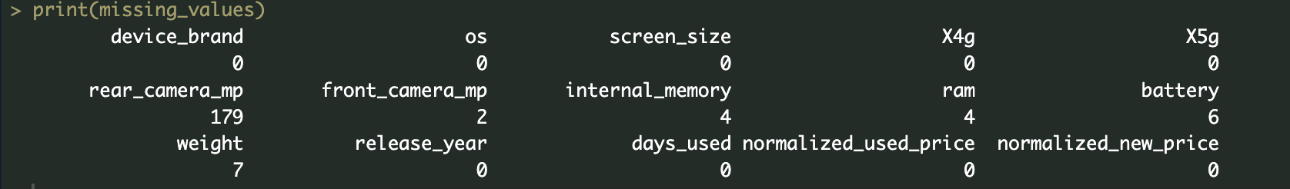Figure 1 Missing values.

Next, we replace missing values in the dataset with the corresponding centroid values from the clusters to which the data points belong. This process is applied to all numeric features, aiming to fill in missing data based on similarities observed within clusters. Following the initial imputation, we check for any remaining missing values in the dataset. Despite the clustering-based imputation, it's possible that certain features still contain missing values.

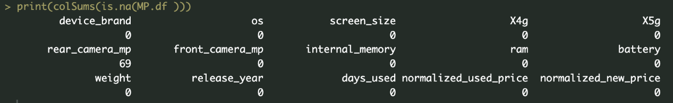

Figure 2 Missing Value still exist.

To address this, we further refine the imputation approach for the rear_camera_mp column. Here, we calculate the median of non-missing values in this column and replace missing values with this median. This additional step aims to ensure comprehensive handling of missing data, specifically focusing on the rear_camera_mp feature.

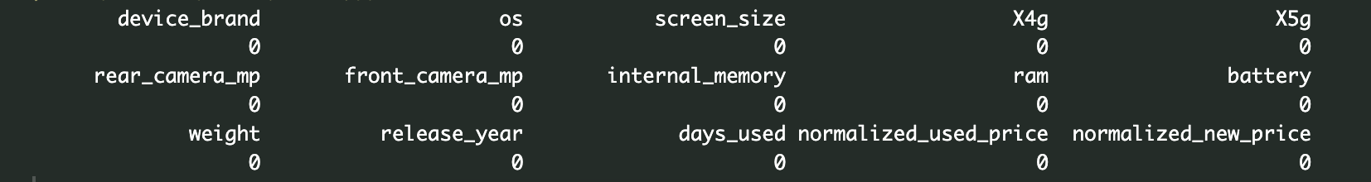

Figure 3 Missing Values Replacement

By utilizing clustering techniques and targeted imputation strategies, the script endeavors to enhance the completeness and accuracy of the dataset, enabling more robust analysis and insights into the characteristics of used devices.

## Check for Zero Values

It's clear that some devices in the dataset have something odd about the front camera resolution as they have zero column.

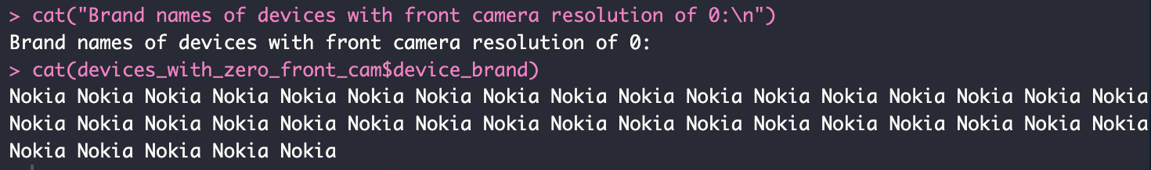

Figure 4 Zero Values



Figure 5 Device without having a front cam.

All these devices shown in fig 5 without having a front_camera_mp belong to Nokia. But before we jump to conclusions, we need to dig deeper. We'll figure out if this means something meaningful or if it's just a missing set in the data.

# Analysis for Numerical Variables

## Box-plot for Numerical Variables with Outliers

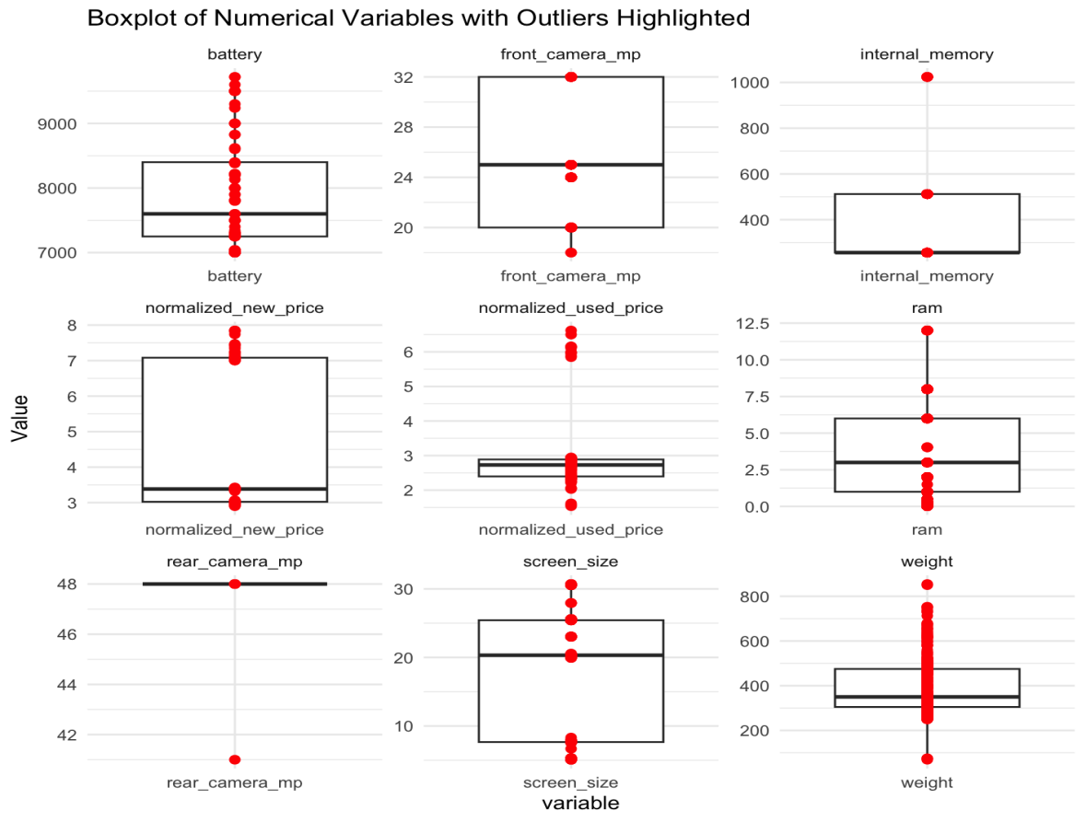

Figure 6 Box Plot

Upon examining the visualizations from fig 6, it's evident that outliers are present in all numerical attributes, suggesting notable deviations from the typical values. The abundance of outliers across attributes warrants further investigation to assess their impact on the analysis.

## Release Year vs Battery

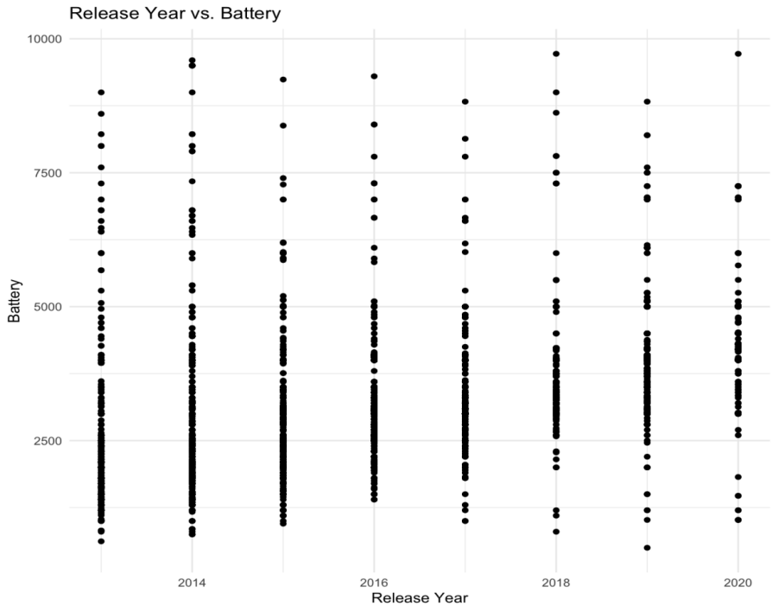

Figure 7 Scatter plot for Release Year vs Battery.

Across various release years, the battery capacities of different brands consistently range from 1250 to 5000. This suggests a common trend in battery specifications among diverse devices, regardless of their launch dates.

## Screen_Size Vs Device_Type

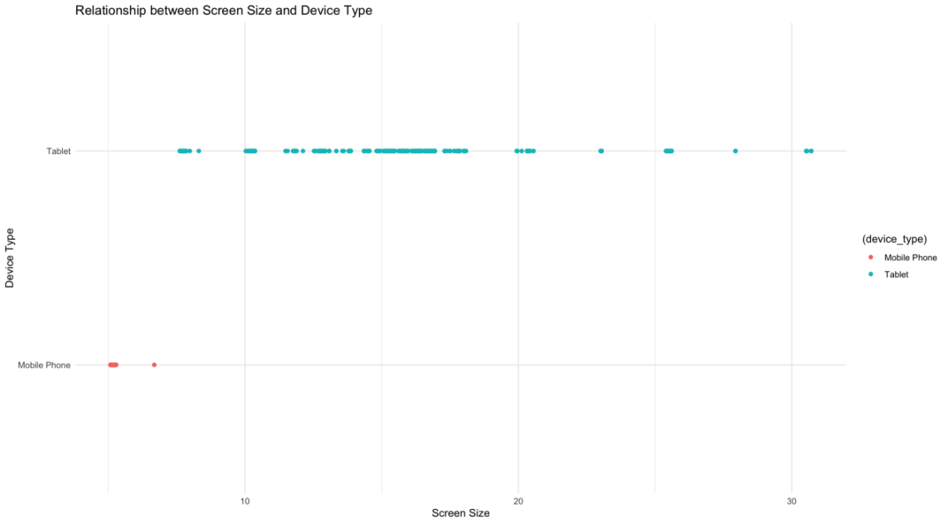

Figure 8 Scatter plot for Relationship between Screen Size and Device Type

The generated plot illustrates the relationship between screen size and device type. Each point on the plot corresponds to a particular device, positioned based on its screen size along the x-axis and its device type along the y-axis. The color of each point distinguishes between different device types, aiding in visual differentiation.

## Distribution of days_used

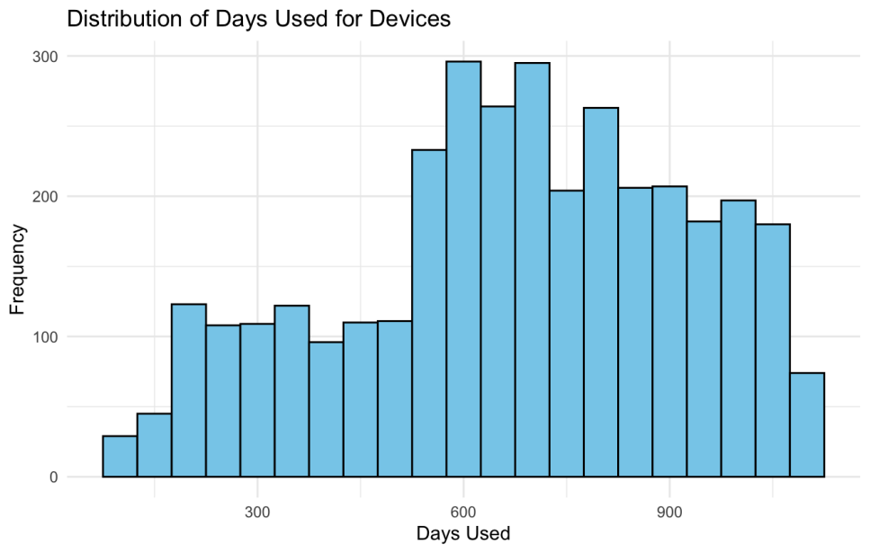

Figure 9 Histogram for distribution of days used for devices.

The histogram highlights a significant trend where the devices exhibit a higher proportion of longer-term usage compared to shorter durations.

## Factors Affecting Device Weight

In addition to battery capacity, several other factors can influence the weight of a mobile device. These factors include screen size, internal memory, RAM etc. Each of these elements interacts in complex ways to contribute to the overall weight of the device. Manufacturers often make trade-offs between features, performance, and weight to meet consumer preferences and market demands.

There is a positive correlation between battery capacity and device weight, meaning that devices with higher battery capacities tend to weigh more. This is likely because batteries themselves contribute to the weight of a device, and larger batteries have higher capacities.

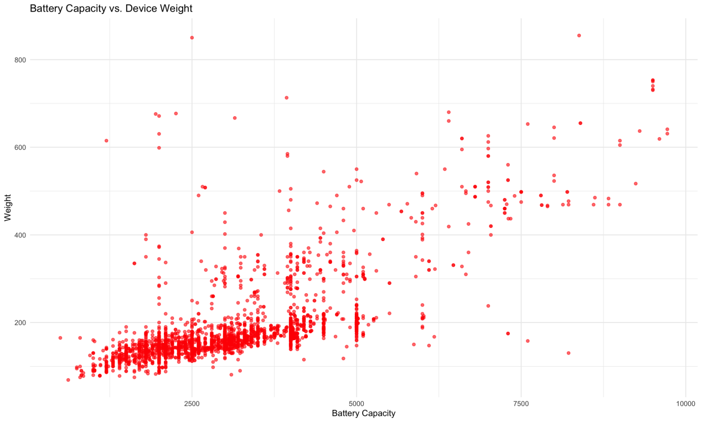

Figure 10 Scatter plot of factors Battery vs weight.

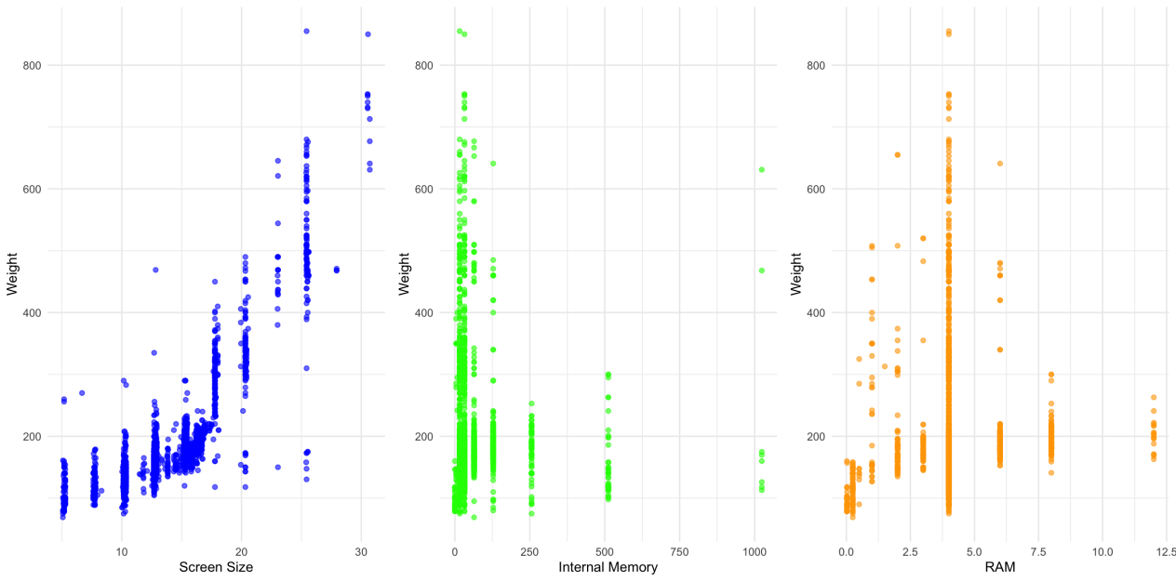

Figure 11 Scatter plot of factors affecting weight.

**Top left:** This scatter plot shows a weak positive correlation between screen size and weight. This means that larger screens tend to be found in heavier devices, but there are also many exceptions.

**Top right:** This scatter plot shows a very weak positive correlation between internal memory and weight. There is almost no visible pattern to the data points, suggesting that there is no clear relationship between internal memory and weight.

**Bottom:** This scatter plot shows a very weak positive correlation between RAM and weight. Like the plot for internal memory, there is no clear pattern to the data points.

Overall, the weight of a mobile device appears to be more strongly influenced by factors other than screen size, internal memory, and RAM. These factors may include the materials used in the device's body, the size and weight of the battery, and other components.

## Distribution of Release Days by Year

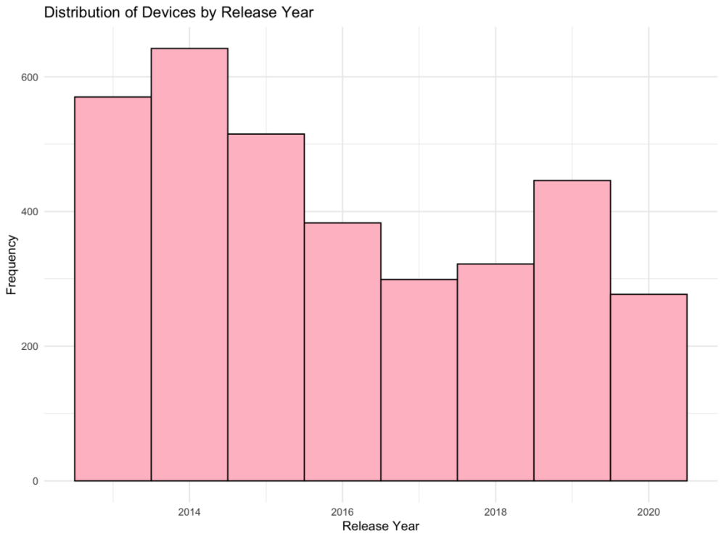

Figure 12 Histogram for distribution of devices by release year.

From fig 11 depicting the distribution of devices by release year, several observations emerge. The year 2014 stands out as the period with the highest number of device releases, followed closely by 2013, 2015, and 2019.

However, it's crucial to recognize that the y-axis doesn't begin at zero, potentially underestimating the true frequency of devices released in each year. This graph provides valuable insights into the historical trends of device releases.

## Normalized_used_price Vs Normalized_new_price

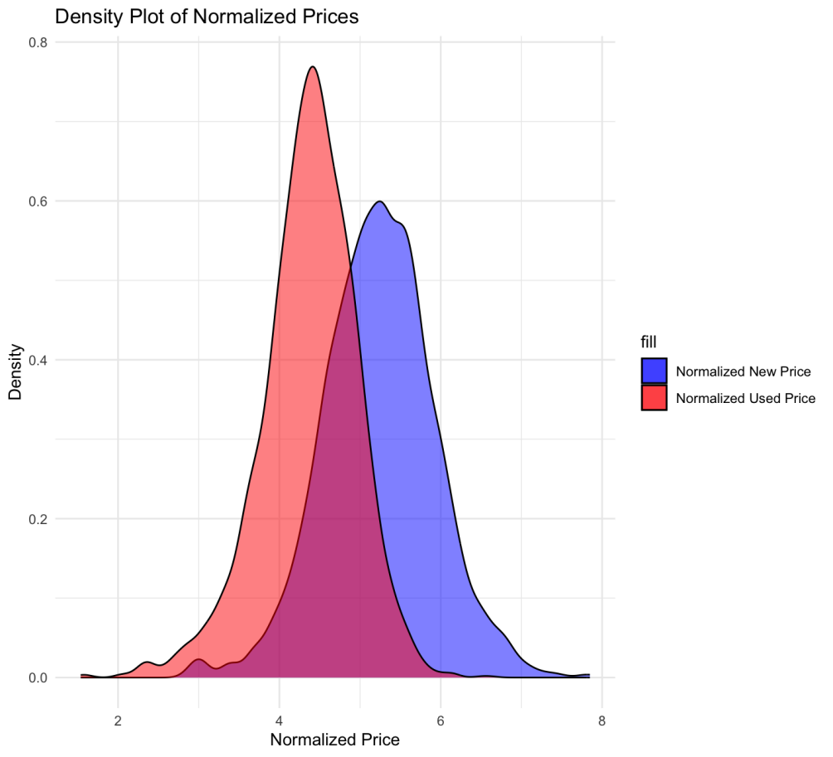

Figure 13 Density plot of normalized prices.

The plot displays two smooth curves representing normalized new prices (in blue) and normalized used prices (in red). Both curves exhibit a bell-shaped distribution, indicating a normal distribution pattern. However, the curve for used prices is slightly left-shifted, suggesting that used phones are generally priced lower than new ones.

The correlation coefficient of 0.834 signifies a strong positive relationship between normalized new and used prices. This means that as the price of new phones increases, the price of used phones tends to increase as well. It confirms the trend that used phones are typically cheaper than new ones, yet the price of used phones rises alongside the price of new ones.

## Analysis Summary for Numerical Attributes

a) The box plots reveal the presence of outliers across all numerical attributes, indicating significant deviations from typical values, warranting further investigation into their impact on the analysis.

b) Battery capacities, ranging from 1250 to 5000 mAh, show consistent trends across various release years, suggesting common specifications among devices regardless of their launch dates.

c) The plot illustrates the relationship between screen size and device type, with each point representing a device positioned based on its screen size and device type. Visual differentiation is aided by color distinctions.

d) The histogram of days_used highlights a higher proportion of longer-term usage compared to shorter duration, indicating usage trends among devices.

e) Factors influencing device weight, including battery capacity, screen size, internal memory, and RAM, show weak positive correlations with weight. However, the weight appears more strongly influenced by other factors beyond these attributes.

f) The histogram of release days by year reveals peaks in 2014, 2013, 2015, and 2019, suggesting significant device release activity during these years.

g) Smooth curves depicting normalized new and used prices indicate a bell-shaped distribution, with used phones priced slightly lower than new ones. The strong positive correlation (0.834) between new and used prices confirms the trend of increasing used prices alongside new ones.

# Analysis for Categorical Variables

## Frequency Distribution of Device Brands - Histogram

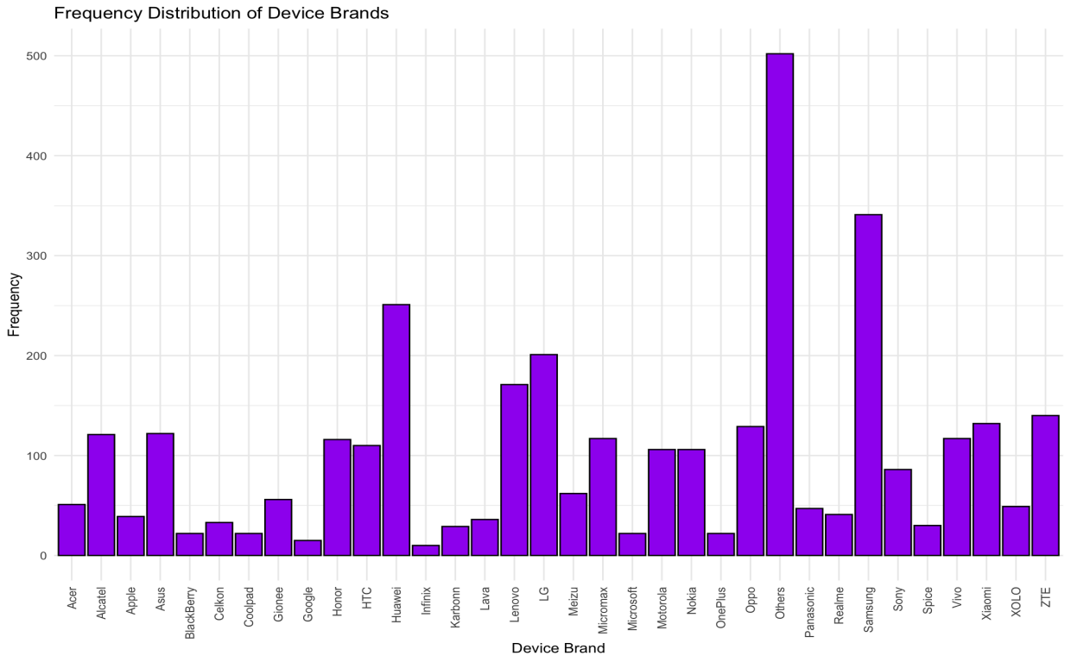

Figure 14 Frequency Distribution of Device Brands

When we cast our gaze upon the visual representation in fig 13, it becomes abundantly clear that brands like Others, Samsung, and Huawei emerge prominently within the dataset.

## Percentage of 4G and 5G availability for Others Brand Devices Histogram

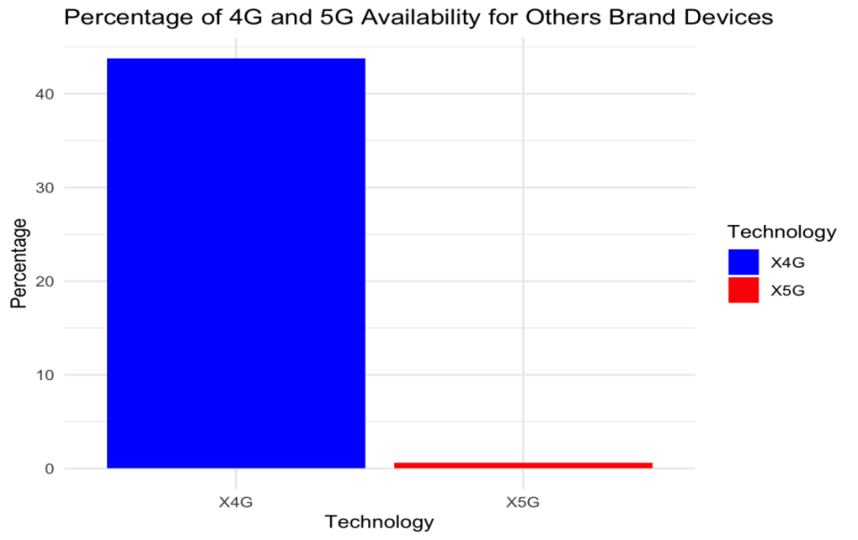

Figure 15 Histogram for % of connectivity ratio present in the dataset.

From fig 14 we see, the "Others" brand has the most devices. When we look closer, we find that most of these devices use 4G rather than 5G. This tells us that for this brand, 4G is more common than 5G.

## Distribution Of OS Types

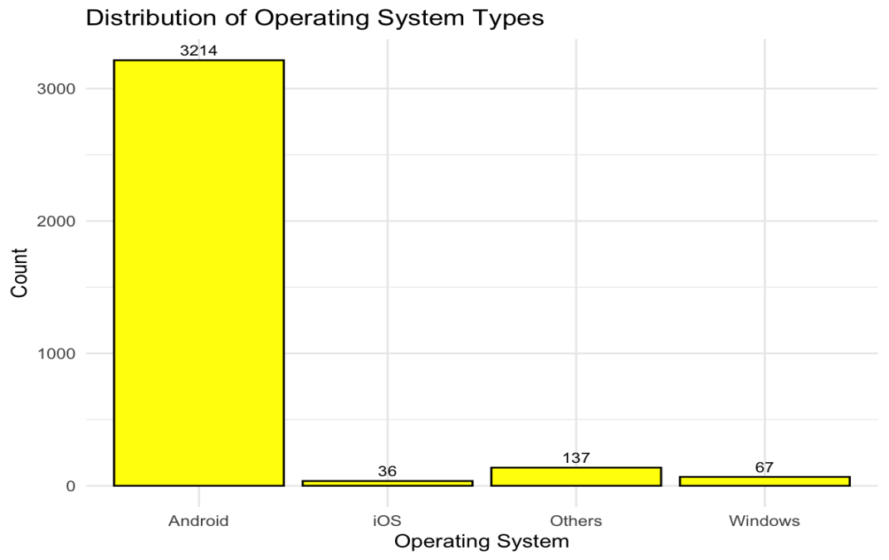

Figure 16 Distribution of OS Types

Looking at the visual, it's clear that Android devices dominate the dataset, outnumbering other operating systems. This suggests that Android is the most prevalent operating system among the devices in our dataset.

## Distribution of Connectivity Type

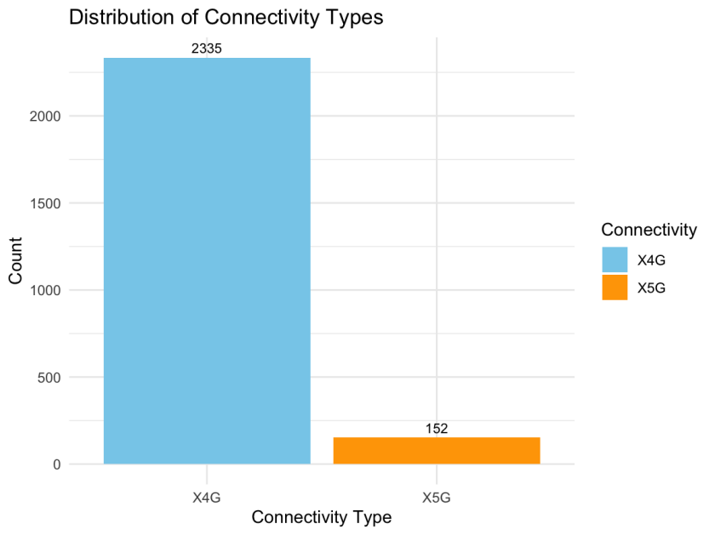

Figure 17 Connectivity type.

In our dataset, there are more devices supporting 4G than 5G, with 967 devices not supporting either. This suggests that many devices still rely on older connectivity options or may not require high-speed network capabilities.

## Analysis Summary for Categorical Variables

a) The histogram reveals that brands like Others, Samsung, and Huawei are prominent in the dataset.

b) The histogram shows that the "Others" brand mostly utilizes 4G connectivity over 5G.

c) Android devices outnumber other operating systems, indicating Android's prevalence.

d) More devices support 4G than 5G in the dataset, with a considerable number not supporting either, suggesting reliance on older connectivity options.

## Analysis with Target Variable

1. **Scatter plot of Numerical Variable Against Normalized Used Price**

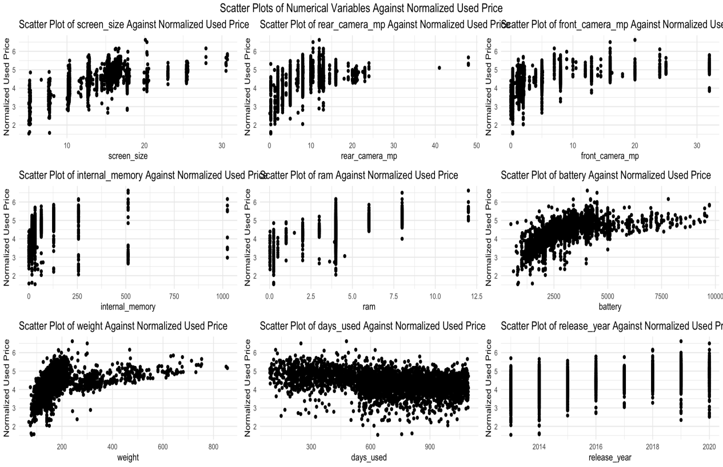

Figure 18 Scatter plot of Numerical Variable Against Normalized Used Price

By examining the scatter plots generated in fig 17, we can intuitively grasp how different numerical characteristics of devices correlate with their normalized used prices. For instance, we may observe that devices with larger screen sizes tend to command higher prices, or that devices boasting higher camera resolutions are associated with increased resale values.

## Box plot of categorical variables against Outcome

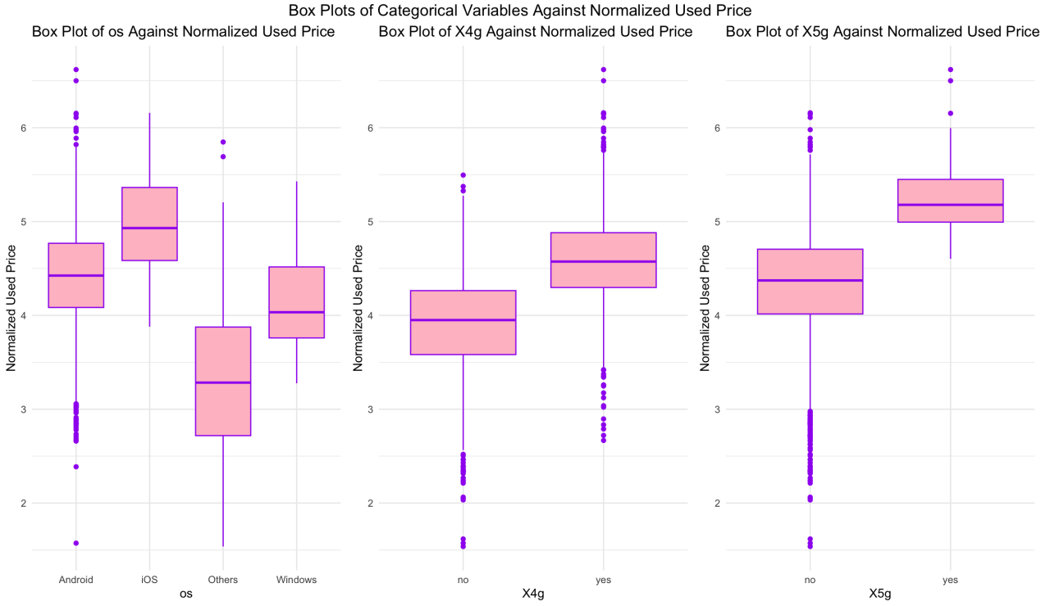

Figure 19 Box plot of Categorical Variables

The visualizations above, comprising box plots depicting the relationship between various categorical attributes (such as brand, operating system, etc.) and the corresponding normalized used prices of devices, provide a comprehensive overview of pricing patterns across different categories.

Each box plot showcases the distribution of prices within a specific category, offering insights into the variability and central tendencies of prices across different groups. Through these visualizations, we can easily identify any significant differences or trends in prices associated with distinct categorical factors, facilitating informed decision-making in pricing strategies and market analysis within the secondary device market.

# Predictor Analysis

The LASSO regression model was trained using the cv.glmnet function . The model was then evaluated using cross-validation for ridge regression, and the resulting curve was plotted to visualize the relationship between the penalty term (lambda) and the mean squared error.

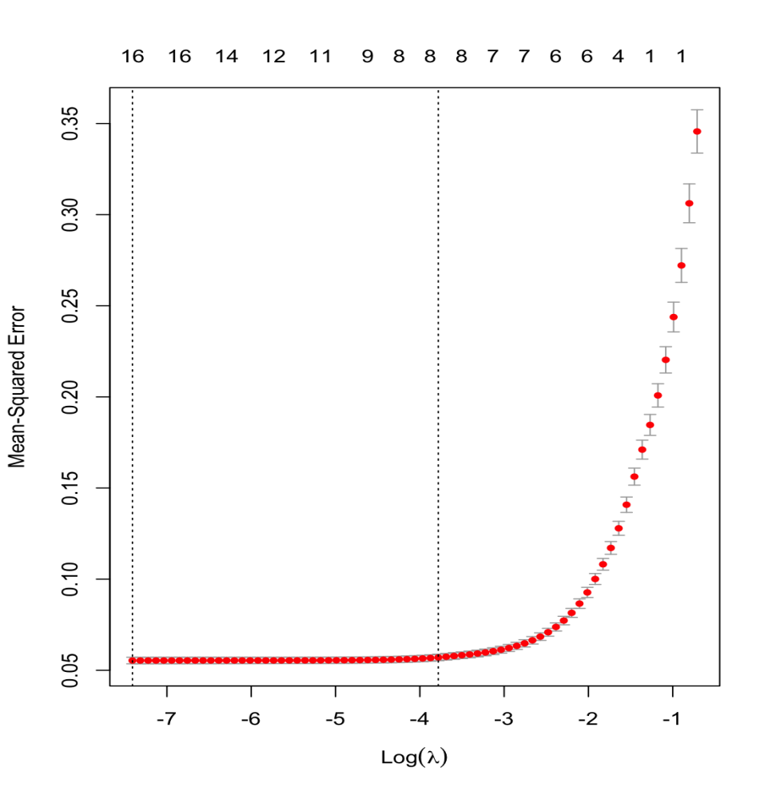

Figure 20 LASSO coefficient profile.

Subsequently, the LASSO coefficient profiles were plotted to display the coefficients of the predictors against the lambda sequence. Vertical lines were added to indicate lambda values corresponding to the minimum mean cross-validated error (lambda.min) and one standard error rule (lambda.1se). These lambda values were annotated on the plot for reference.

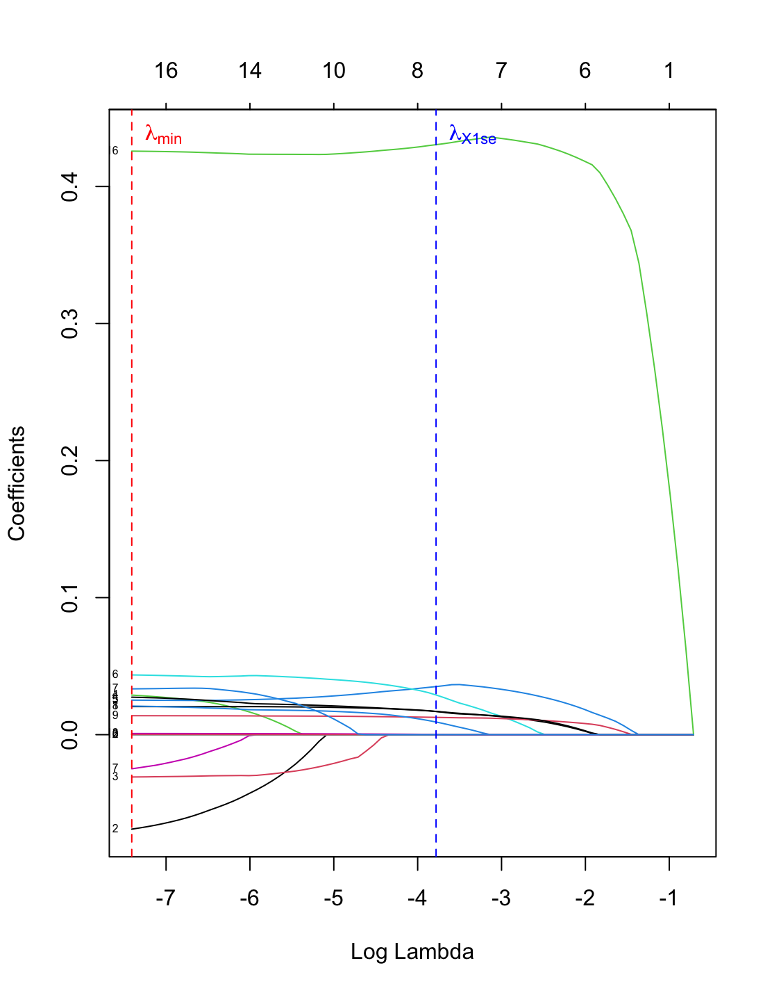

Figure 21 LASSO coefficient.

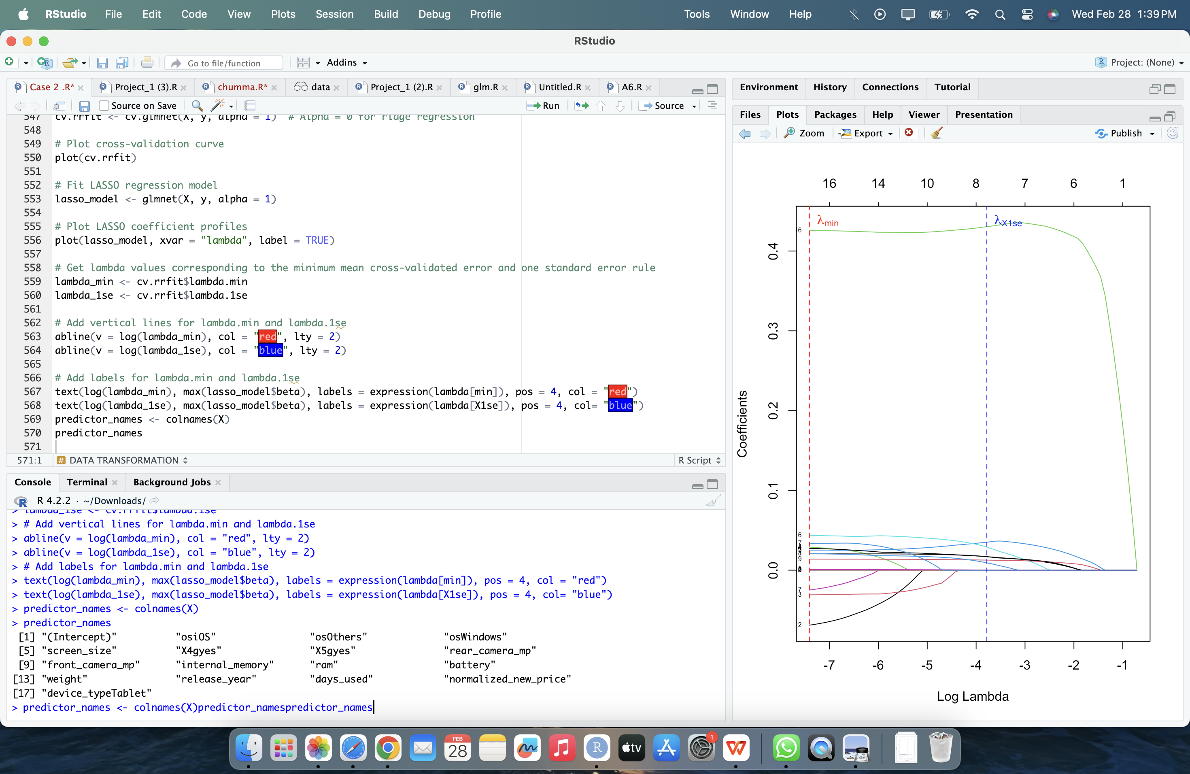

The predictor names used in the model were extracted and stored in the predictor_names variable.

# Data Transformation

1. **Creating Dummy Variables for Operating System:** Dummy variables for the "os" column were created using the model.matrix() function. The original "os" column was then removed, and the dummy variables were appended to the data frame.
2. **Categorizing Device Type**:

Categorizing devices based on their screen size. Employing logical conditions, we differentiated devices into three primary types: Mobile, Tablet, and 2-in-1 Convertible.

**3)Removal of Redundant Columns:**

Following these transformations, we streamlined the dataset by removing redundant columns, specifically 'X4g' and 'X5g', as their information was integrated into the connectivity classification.

## Dimension Reduction

After computing the correlation matrix, it appears that the results may not precisely capture the importance of dimension reduction for prediction purposes.

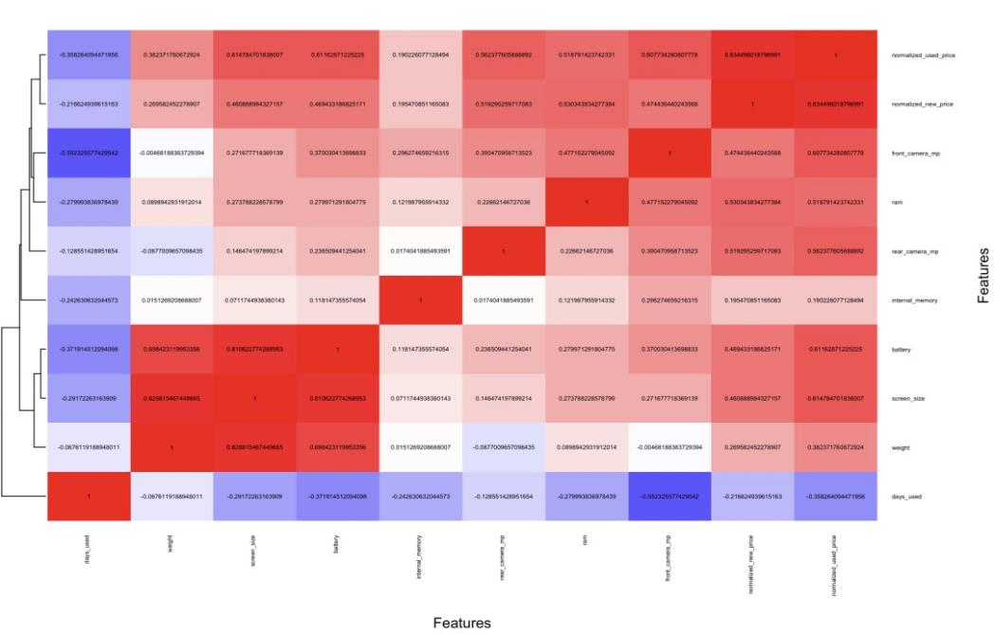

Figure 22 Correlation Matrix

Based on the analysis conducted, it appears that dimension reduction is not necessary for this dataset. Each feature seems to play a unique role, and there are no redundant on highly correlated variables that could be removed as we can lose some valuable information.

Therefore, we can proceed with the full set of features for our analysis and modeling, as each variable contributes independently to the predicted outcome.

# Data Partitioning

In partitioning the dataset with a total of 3454 observations, 50% (1727 observations) were allocated to the training set, 30% (1036 observations) to the validation set, and the remaining 20% (691 observations) to the test set. This partitioning was performed using random sampling with a seed value of 2024 to ensure reproducibility.

By partitioning the data into separate training, validation, and test sets, we ensure that our machine learning model is trained effectively, fine-tuned appropriately, and evaluated accurately. This process helps to build robust and reliable models that can generalize well to new data, enhancing their usefulness and applicability in practical settings.

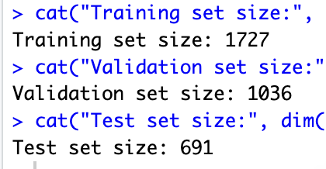

Each partition was extracted from the dataset based on the generated indices. This partitioning strategy allows for effective model training, validation, and evaluation, ensuring robustness and reliability in assessing model performance. narrative voice easy words

# Models Selection for Goal-1

**Goal 1**: The objective shifts to regression, aiming to predict the normalized used price of mobile phones based on provided attributes, with "normalized_used_price" again serving as the target attribute.

**Approach**

To achieve this goal, we can consider using two regression models:

1. Stepwise regression
2. Regression Tree

**Selected Variables**

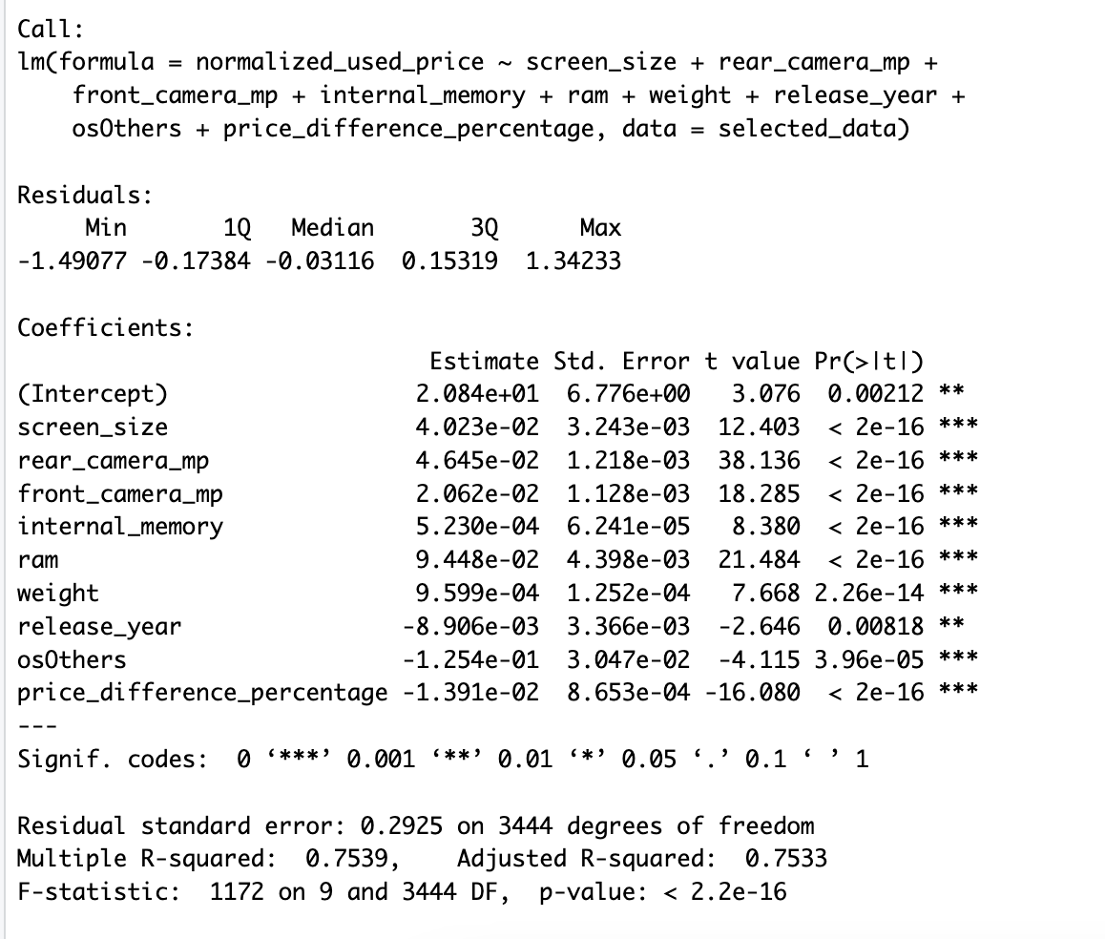

## Model 1: Stepwise Regression

After conducting regression analysis on our dataset, we employed linear regression models to predict the prices of used devices. Initially, we constructed a comprehensive linear regression model using all available features, providing a detailed overview of the relationships between predictors and the normalized used price.

### Model Evaluation and Performance

After encountering multicollinearity issues during our initial regression analysis, we adapted our approach by implementing stepwise regression. This method allowed us to systematically select the most relevant predictors while mitigating the impact of multicollinearity.



Figure 23 Stepwise Regression Summary

Through stepwise regression, we identified a subset of key predictors that significantly influence the normalized used price of devices. These predictors include screen size, rear camera megapixels, front camera megapixels, internal memory, RAM, weight, release year, operating system (OS), and price difference percentage.



Following model refinement, we evaluated the performance of our stepwise regression model on the validation. The validation Mean Absolute Error (MAE) provided valuable insights into the model's predictive accuracy on unseen data, helping us find its effectiveness in real-world scenarios.

## Model 2: Regression Tree

After training our regression tree model using the selected variables, we assessed its performance on the validation dataset. The validation Mean Absolute Error (MAE) served as a crucial metric, indicating how closely the model's predictions aligned with the actual prices in the validation set.

### Model Evaluation and Performance



The validation MAE uses the regression tree with selected variables, showcasing the model's effectiveness in accurately predicting the prices of used devices in real-world scenarios. This metric underscores the reliability of our model in providing valuable insights for pricing strategies and decision-making in the market for used electronic devices.

## Implication and model selection

After conducting our regression analysis, we've determined that our models exhibit reasonable performance in predicting the prices of used devices.

|  |  |  |
| --- | --- | --- |
| Model | STEPWISE REGRESSION | REGRESSION TREE |
| MAE | 0.2106 | 0.2246 |

Based on these findings, I recommend the stepwise regression model as our preferred choice for predicting used device prices. Its lower validation MAE indicates better accuracy in predicting prices compared to the regression tree model. To validate its performance further, we should assess its accuracy on the test dataset.

# Classification for Goal-2

**Goal 2:** To classify mobile phones as high priced or low priced based on their attributes, with the target attribute being "normalized_used_price".

**Approach:** We classified mobile phones into low and high-priced variants by creating columns for price difference, depreciation, release year, and days used, simplifying analysis without utilizing a specific model.

## Columns Created:

### Calculating Price Difference

We began by computing the price difference by subtracting our predicted prices from the original prices of the devices when they were brand new. This information was recorded in the "price_difference" column.

### Categorizing Depreciation

Next, we classified the devices into low, medium, and high depreciation categories based on how much their prices dropped compared to their original prices. Each device was labeled accordingly in the "depreciation_category" column.

### Categorizing Release Year and Days Used

Further categorization involved labeling devices as "old" or "new" release year categories and "short-term" or "long-term" days used categories, recorded in the "release_year_category" and "days_used_category" columns, respectively.

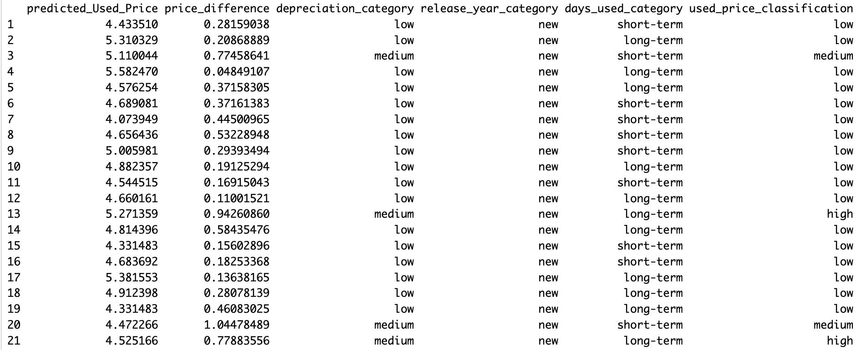

Figure 24 Columns Added for Implication

## Implication

The process of classifying mobile phones into low and high-priced variants based on their attributes greatly aids in achieving our goal of understanding pricing dynamics. By creating columns for price difference, depreciation, release year, and days used, we simplify the analysis process, allowing for a straightforward comparison of devices.

Firstly, calculating the price difference as shown in fig 23 provides a clear insight into how much a device's price has changed since its original release, giving us a measure of its depreciation over time. This information, recorded in the "price_difference" column, serves as a crucial factor in determining the device's overall pricing category.

Secondly, categorizing depreciation, release year, and days used further refines our classification system. By labeling devices into low, medium, and high depreciation categories, and classifying them based on release year and days used, we capture additional nuances that contribute to their pricing variations.

These categorizations, recorded in the respective columns, provide a comprehensive framework for classifying devices as either low or high-priced variants, ultimately helping us discern patterns and make informed decisions in the mobile phone market.

**Combined Analysis of Regression and Classification**

## Regression

**Models Used:** Stepwise Regression & Regression Tree

Both models exhibit reasonable performance in predicting used device prices, with the stepwise regression model showing slightly better accuracy with a lower validation MAE.

### Test accuracy of Selected Model (Stepwise Regression)

The Test MAE was approximately 0.2013. This suggests that the model's performance on the test dataset was slightly better, with predictions deviating by about 20% from the actual prices.



Overall, the stepwise regression model demonstrates promising accuracy in predicting used device prices, with slightly improved performance on the test dataset compared to the validation dataset.

## Classification

**Approach:** The classification process adds a layer of understanding by categorizing devices into low and high-priced variants based on attributes like depreciation, release year, and days used.

**Outcome:**

Based on the classification results, we identified the top 5 brands for each predicted price category: low, medium, and high. This stepwise approach simplifies the process by directly classifying predicted prices into meaningful tiers for analysis and decision-making.

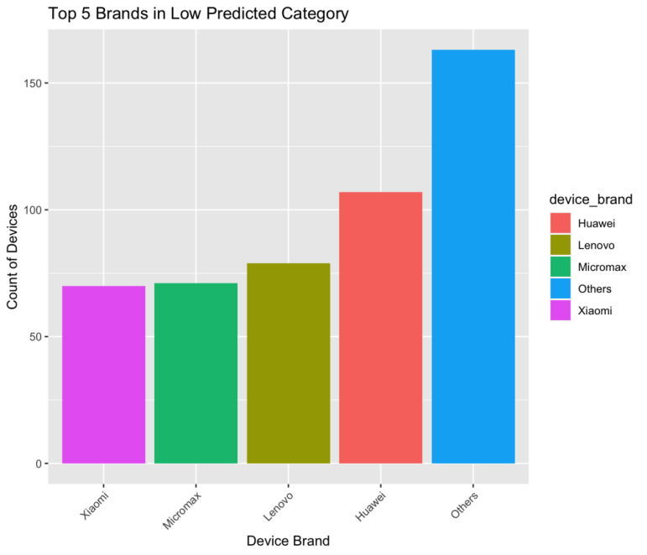

Figure 25 Top 5 brands in Low Predicted Category

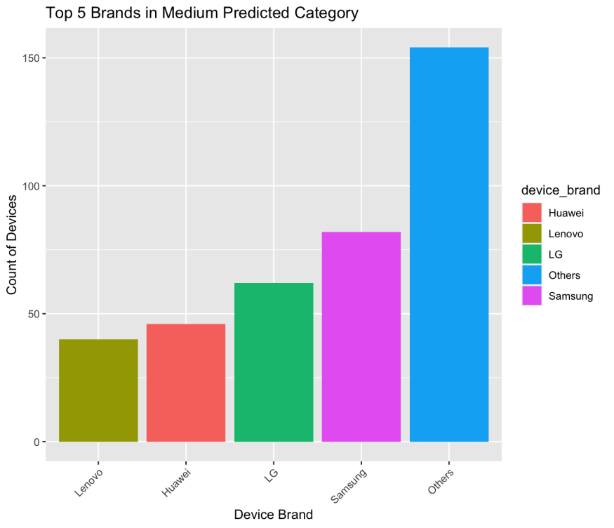

Figure 26 Top 5 brands in Medium Predicted Category

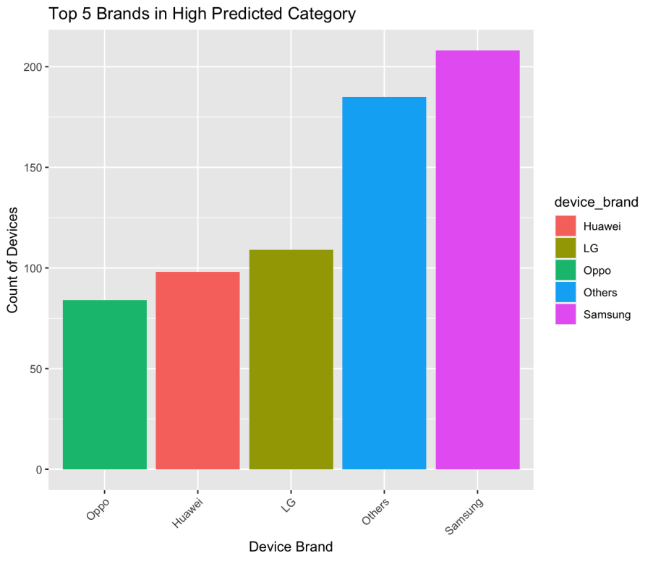

Figure 27 Top 5 brands in High Predicted Category

By examining figures 25, 26, and 27, we can identify the top 5 brands in each category. Consumers are advised to consider these brands as potential good fits for their needs. By further evaluating other reviews and specifications, they can determine the best device for them. This process simplifies the decision-making process, helping consumers make informed choices that align with their preferences and requirements.

# Conclusion

Our project aimed to delve into the pricing dynamics of used mobile phones using advanced analytics techniques. We conducted exploratory data analysis on various features like screen size, camera specifications, internal memory, and release year to understand their impact on pricing in the secondary market. Through mathematical modeling, we identified key predictors influencing prices and employed both regression and classification techniques.

In regression modeling, we utilized stepwise regression to address multicollinearity issues, selecting relevant predictors to enhance predictive accuracy. We also trained a regression tree model and evaluated its performance. For classification, we categorized predicted prices into low, medium, and high groups based on regression model predictions, offering valuable insights for consumers.

Our analysis revealed pricing strategies within the mobile phone market, providing actionable insights for consumers and industry stakeholders. The stepwise regression model emerged as our preferred choice for predicting used device prices due to its slightly better accuracy. By categorizing predicted prices into meaningful tiers and identifying top brands within each category, we offer consumers guidance for selecting the right device based on budget and preferences.

Additionally, our findings provide recommendations for improving pricing strategies and decision-making processes within the mobile phone industry. Overall, our project highlights the importance of leveraging advanced analytics to gain insights into pricing dynamics and facilitate informed decision-making in the ever-evolving landscape of mobile technology.

# Business Recommendation

The utilization of predictive models facilitates optimized pricing strategies, enabling businesses to set competitive prices that resonate with market demand and align with device attributes. By analyzing historical data and market trends, these models provide valuable insights into pricing dynamics, allowing businesses to adjust their pricing strategies dynamically to stay ahead of the competition. Moreover, the integration of predictive analytics in pricing decisions ensures that businesses can strike a balance between profitability and market penetration, enhancing overall revenue generation.

Furthermore, predictive modeling supports inventory management by prioritizing procurement and promotion of devices with higher demand. By accurately forecasting demand and identifying trends, businesses can optimize inventory levels, minimize carrying costs, and improve turnover rates. This proactive approach to inventory management ensures that businesses maintain optimal stock levels to meet consumer demands efficiently while mitigating the risks associated with excess inventory or stockouts. Overall, leveraging predictive analytics empowers businesses to make data-driven decisions, enhancing operational efficiency and maximizing returns across various business functions.

# Executive Summary

**Nikroshitha A Notani**

**March 20, 2024**

**Business Opportunities**

In today's dynamic mobile technology market, understanding the pricing dynamics of used mobile phones is crucial for both consumers and providers alike. Our project analysis investigates the combination of various factors influencing consumer decisions in the secondary mobile phone market through advanced analytics techniques.

**Solution**

Our analysis revealed significant insights into market trends, consumer preferences, and pricing patterns. For instance, we observed that Android devices dominate the dataset, while brands like Samsung and Huawei emerge prominently. Additionally, we found a strong positive correlation between normalized new and used prices.

Further, we conducted predictor analysis, data transformation, and dimension reduction assessments to prepare the data for modeling. We partitioned the dataset into training, validation, and test sets to ensure robust model evaluation. Moving forward, we outlined regression model selection tailored to our goals, including options such as stepwise regression and regression tree. By providing actionable insights derived from our models, we classified our outcome into three labels which aim to empower stakeholders in the mobile phone industry to make informed decisions and navigate the ever-evolving market landscape effectively with better profits.

Project 3: Mortgage payback behavior analytics

Table of Contents

1 Introduction………………………………………………………………………………………………………………….. 60

2 Business goal………………………………………………………………………………………………………………… 60

3 Analytic goal…………………………………………………………………………………………………………………. 61

4 Data Preprocessing ………………………………………………………………………………………………………..61

4.1 Attribute Definition…………………………………………………………………………………………………….61

5 Data Exploration……………………………………………………………………………………………………………. 64

5.1 Check for Missing values…………………………………………………………………………………………….64

5.2 Check for Zero’s………………………………………………………………………………………………………..65

6 Data Transformation………………………………………………………………………………………………………. 67

7 Dimension reduction……………………………………………………………………………………………………… 68

8 Data Exploration……………………………………………………………………………………………………………. 69

8.1 Numerical variables…………………………………………………………………………………………………..69

8.2 Categorical Variables………………………………………………………………………………………………..70

9 Correlation Analysis…………………………………………………………………………………………………. 72

10 Data partitioning methods…………………………………………………………………………………………. 72

11 Classification Models………………………………………………………………………………………………… 73

11.1 Goal 1: Predicting Loan Outcome for Active Borrowers………………………………………………..73

11.1.1 Model Analysis………………………………………………………………………………………………….73

11.2 Goal 2: Assessing Loan Eligibility for New Customers…………………………………………………73

11.2.1 Model Analysis…………………………………………………………………………………………………74

12 Model Selection and Holdout data………………………………………………………………………………. 74

12.1 For Goal-1…………………………………………………………………………………………………………….74

12.2 For Goal-2…………………………………………………………………………………………………………….74

13 Combined Analysis…………………………………………………………………………………………………… 75

13.1 Model Performance Evaluation:……………………………………………………………………………….75

13.2 Model Selection and Holdout Data:………………………………………………………………………….75

14 Business Recommendations……………………………………………………………………………………… 75

15 Executive Summary………………………………………………………………………………………………….. 77

# Introduction

The mortgage dataset provided is a comprehensive collection of panel data, offering insights into the origination and performance metrics of residential U.S. mortgages. With observations spanning 60 periods, this dataset encompasses information on 50,000 mortgage borrowers. It's essential to note that the periods within the dataset have been identified, likely for privacy and confidentiality reasons.

This dataset mirrors the complexities of the real-world mortgage market, where loans may originate before the commencement of the observation period. Consequently, some loan observations may be censored as loans mature or borrowers opt to refinance their mortgages. Understanding this dataset's structure and underlying dynamics is crucial for various analytical purposes, including risk assessment, financial modeling, and policy formulation within the mortgage industry. By delving into the dataset's intricacies, researchers and analysts can uncover valuable insights that contribute to informed decision making and strategic planning in the realm of residential mortgage financing.

# Business goal

The main aim of this project is to help banks and lending institutions make better decisions about managing their mortgage portfolios. By using data analytics, we want to reduce the risks involved in mortgage lending, make loans perform better, and increase profits. Ultimately, our goal is to make sure that decisions about mortgage lending are smart and efficient, which will keep things financially stable and make customers happy.

# Analytic goal

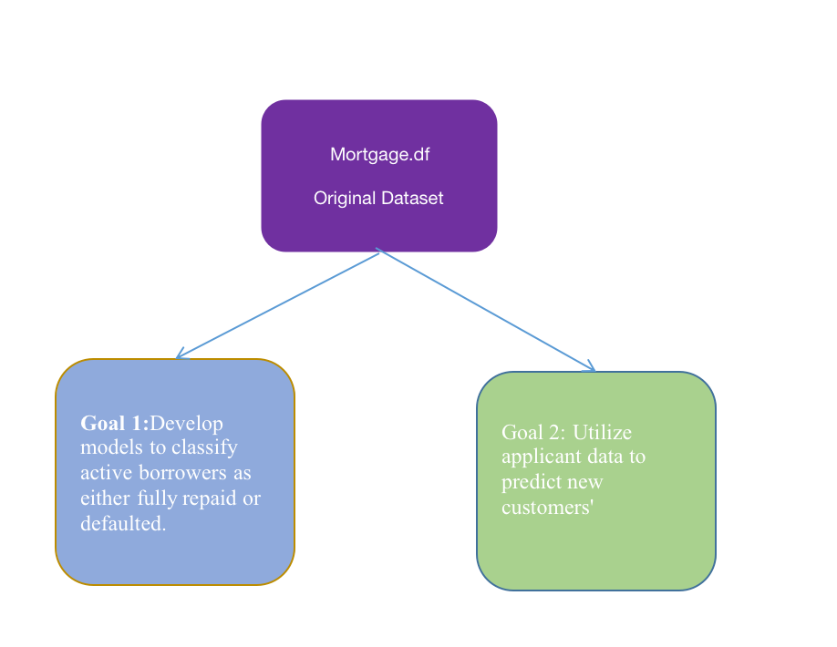

Figure 1 Analytic Goal

Build models to classify loans into default and non-default categories based on borrower and loan characteristics, facilitating targeted risk mitigation strategies and enhancing overall portfolio performance.

**Goal 1:** Develop models to classify active borrowers as either fully repaid or defaulted, aiding risk management.

**Goal 2:** Utilize applicant data to predict new customers' loan repayment or default, optimizing portfolio performance and minimizing losses.

# Data Preprocessing

## Attribute Definition

**1. "id":** This variable represents the unique borrower identifier in the dataset. It allows for the tracking and differentiation of individual borrowers and their associated loan information throughout the dataset, enabling personalized analysis.

**2. "time":** The timestamp variable records the moment when observations were made in the dataset. It serves as a critical component for analyzing temporal changes in loan performance, economic indicators, and borrower attributes over time, providing insights into trends and patterns.

**3. "orig_time":** This timestamp variable marks the origination or initiation time of the loan in the dataset. It signifies the beginning of the loan's lifecycle and is essential for understanding the loan's age, as well as for analyzing various loan characteristics and performance metrics over time.

**4. "first_time":** The timestamp variable indicates the initial observation time for borrowerrelated data in the dataset. It is significant for tracking the inception of borrower data and for analyzing temporal trends or changes in borrower attributes from the first recorded instance.

**5. "mat_time":** This timestamp variable denotes the maturity or full repayment time of the loan in the dataset. It represents the end of the loan's term and is crucial for analyzing the duration of the loan and its repayment timeline, providing insights into the completion of the loan lifecycle.

**6. "balance_time":** Represents the outstanding balance of the loan at the observation time, comprising both principal and accrued interest. This metric offers insights into the borrower's remaining financial obligation and the progress of loan repayment.

**7. "LTV_time":** Indicates the LoantoValue ratio at the observation time, providing a measure of borrower equity and aiding lenders in assessing loan risk. Higher LTV ratios suggest increased borrower leverage and potentially higher default risk.

**8. "interest_rate_time":** Reflects the interest rate charged on the loan at the observation time, influencing borrowing costs and loan risk. Monitoring changes in interest rates over time is crucial for understanding their impact on borrowing expenses and assessing overall loan risk.

**9. "hpi_time":** Represents the House Price Index at the observation time, capturing fluctuations in residential property prices and trends in the housing market. Analysis of HPI data enables stakeholders to assess the health and dynamics of the real estate market.

**10. "gdp_time":** Indicates the Gross Domestic Product (GDP) growth rate at the observation time, offering insights into economic performance and trends. Positive GDP growth signifies economic expansion, while negative growth indicates contraction, influencing various aspects of the economy and financial markets.

**11. "uer_time":** Reflects the unemployment rate at observation, providing insights into labor market conditions and overall economic health. Higher unemployment rates may indicate economic weakness, while lower rates suggest a robust job market.

**12. "REtype_CO_orig_time":** Indicates the property type at loan origination, specifically categorizing residential real estate securing the mortgage as a condominium. This classification helps in understanding the nature of the properties involved in the loan portfolio.

**13. "REtype_PU_orig_time":** Represents the property type at loan origination, distinguishing residential real estate securing the mortgage as a planned urban development. This categorization aids in analyzing the composition and distribution of properties within the mortgage dataset.

**14. "REtype_SF_orig_time":** Describes the property type at loan origination, identifying residential real estate securing the mortgage as a singlefamily home. Understanding property types assists in assessing the diversity and risk profile of the loan portfolio.

**15. "investor_orig_time":** Binary variable indicating the borrower's investor status at loan origination, with a value of 1 signifying the borrower was an investor and 0 indicating otherwise. This variable helps differentiate between investor and noninvestor borrowers, offering insights into the composition of the borrower pool.

**16. "balance_orig_time":** Represents the outstanding loan balance at origination, reflecting the initial amount borrowed by the borrower.

**17. "FICO_orig_time":** Denotes the borrower's credit score at loan origination, serving as a measure of creditworthiness used by lenders.

**18. "LTV_orig_time":** Indicates the LoantoValue ratio at origination, evaluating the initial risk associated with the loan based on the borrower's equity in the property.

**19. "Interest_Rate_orig_time":** Represents the interest rate on the loan at origination, determining the cost of borrowing for the borrower.

**20. "hpi_orig_time":** Reflects the House Price Index at loan origination, offering insights into the property market's value trends.

**21. "default_time":** Binary variable indicating whether the loan defaulted at observation, with 1 denoting default and 0 indicating otherwise.

**22. "payoff_time":** Binary variable indicating whether the loan was paid off at observation, with 1 denoting payoff and 0 indicating otherwise.

**23. "status_time":** Categorical variable indicating the loan's status at observation, categorized as default, payoff, or nondefault/nonpayoff.

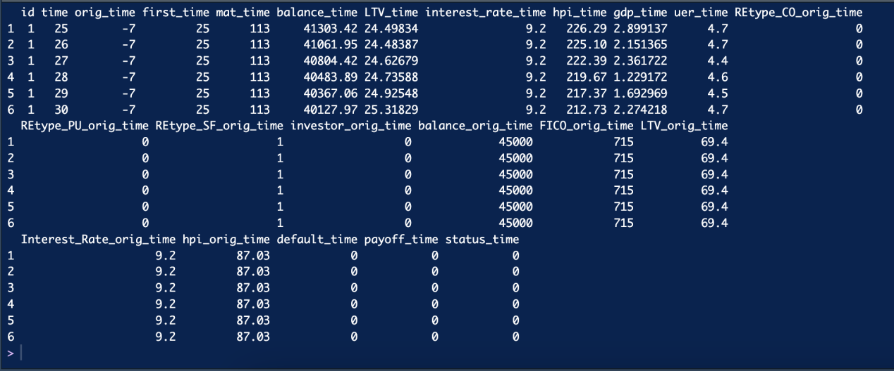

Figure 2 Sample Data

# Data Exploration

## Check for Missing values

After executing some entries in the LTV_time column was found to be missing as shown in figure 3.

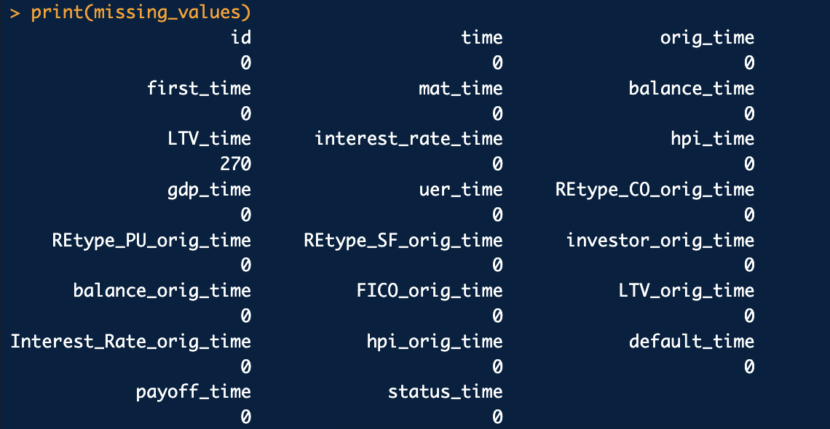

Figure 3 Missing values.

A function was implemented to determine the Loan-to-Value (LTV) ratio using specified balance and value data. Following this, the function is invoked to calculate the LTV ratio for every entry within a dataset.

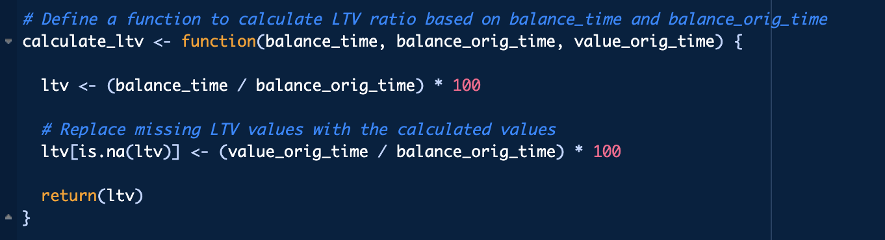

Figure 4 Replacement of missing values

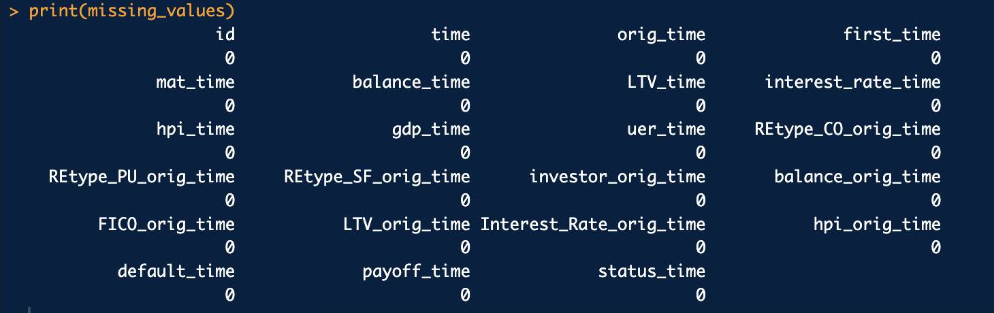

Figure 5 Missing values Handled.

To address this, calculations based on original values were employed to populate these missing entries as shown in figure 5.

## Check for Zero’s

Each zero value carries specific information about the status or characteristics of the mortgage loans in the dataset.

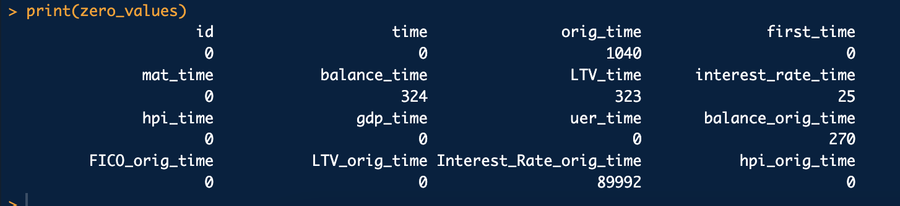

Figure 6 Checking for Zero's

**Orig_time:** This tells us when each mortgage loan started. If it's negative, it means the loan started before the observation period began. If it's zero, it could mean the loan started at the beginning of the observation period or that we're missing the start date.

**Balance_time:** When this is zero, it means the borrower has paid off their loan completely. They don't owe anything anymore.

**LTV_time:** A zero here means the borrower has paid off the entire loan, so they don't owe anything anymore. Since the LoantoValue ratio is about comparing the loan amount to the property value, if there's no loan amount left, the ratio is zero.

**Interest_rate_time:** Zeros could mean different things. For example, they might show up when loans have special deals with no or very lowinterest rates, like special offers or introductory periods.

**Balance_orig_time:** Zeros suggests borrowers have finished paying off their loans entirely. They're done with their payments.

**Interest_Rate_orig_time:** Zeros here suggest that when the loans were started, there wasn't any interest rate recorded. This might be because the information wasn't available or wasn't recorded when the loan began.

# Data Transformation

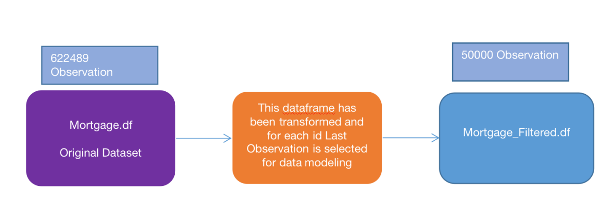

Figure 7 Data being transformed for modeling.

1. **time: Adding Observation Count column.**

Adding a new column indicating the count of observations for each borrower with time and unique id. After formed we identified borrowers with only one observation for default or paid loan and filtered out them from the dataset.

1. **orig_time:** Each value in the orig_time column represents a quarter before the current observation (time). It then calculates the actual origination timestamp by adding the number of quarters to the time column.
2. **mat_time:** After converting orig_time and mat_time to Date objects, we calculate the loan duration in days and then convert it to years. Finally, it prints the updated dataset with the newly added loan_duration_days and loan_duration_years columns.
3. **balance_time:** We calculate the difference between consecutive rows' balance_time for each ID, potentially identifying missing payments and storing the count in a new column called Missing_Payments.

**4)LTV_time:** we calculate the average LoantoValue (LTV) ratio for each id group and stores the result in a new column named avg_LTV

**5) Combine Property Types**

**REtype_combined:** Create a new variable REtype_combined in the Mortgage.df dataframe. This variable combines information from REtype_CO_orig_time and REtype_PU_orig_time, categorizing properties as "CO" (Condominium), "PU" (Planned Urban Development), or "SF" (SingleFamily Home).

1. **Identify irregular payments:** This condition checks if the difference in balance is greater than 0. If it is, it means there's a payment made, so it assigns 0 to missing_payments. Otherwise, it takes the absolute value of the difference, indicating the number of missing payments.

**7) Categorize Interest Rate:** To determine whether the interest rate is fixed or variable for each borrower ID, we'll examine if the interest rate remains consistent across all observations associated with that ID. If the interest rate remains constant, we'll label it as "Fixed" and assign a value of 1 to a new column. Conversely, if the interest rate varies, we'll label it as "Variable" and assign a value of 0 to the new column.

# Dimension reduction

By removing the columns for "default_time" and "payoff_time," we're simplifying the dataset and getting rid of repetitive data as shown in fig 13. The "status_time" column already tells us whether a loan defaulted or was paid off, so keeping these extra columns doesn't give us any new useful information.

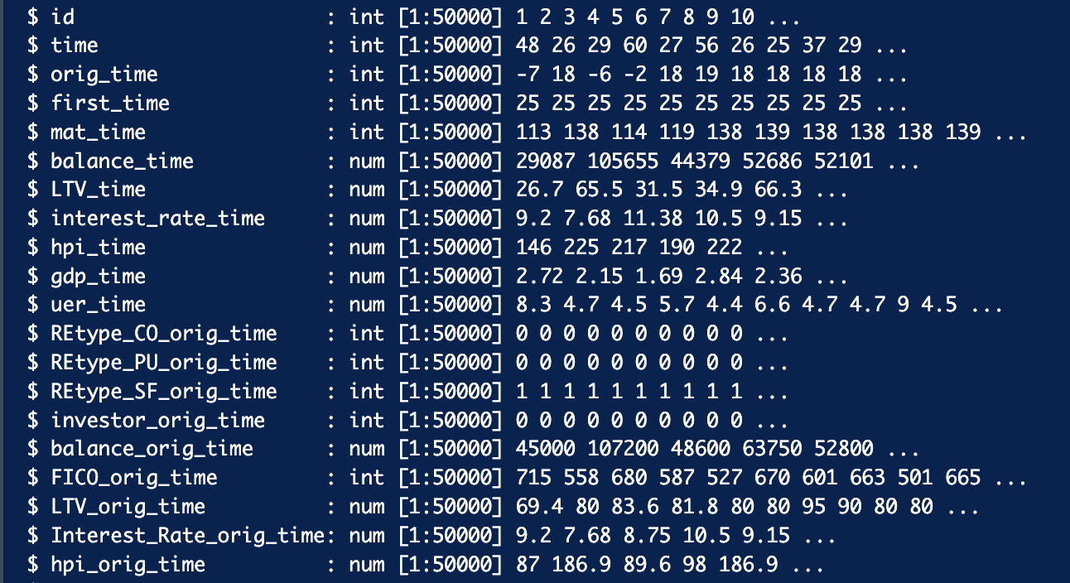

Figure 8 Data after transformation.

# Data Exploration

## Numerical variables

1. **Interest Rate**

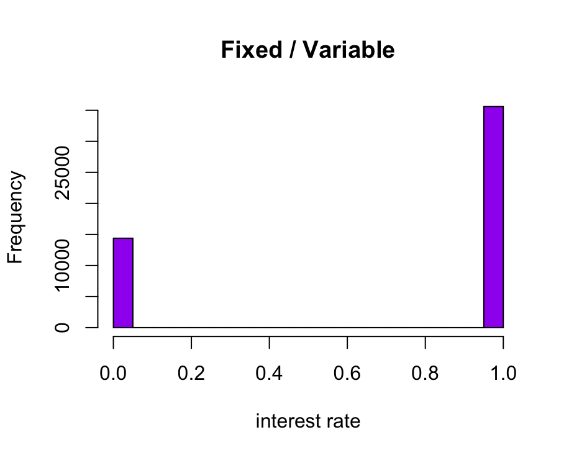

Figure 9 Intrest rate type

The histogram in fig 9 depicts the distribution of mortgage borrowers categorized by their interest rate type, whether fixed or variable. In this visualization, the x axis represents the interest rate category, while the y axis represents the frequency of borrowers. The graph is titled "Fixed / Variable," indicating the two categories being compared. The purple color palette enhances the visual appeal, making it easier to discern the distribution between fixed and variable interest rates.

1. **Histogram of status_time**

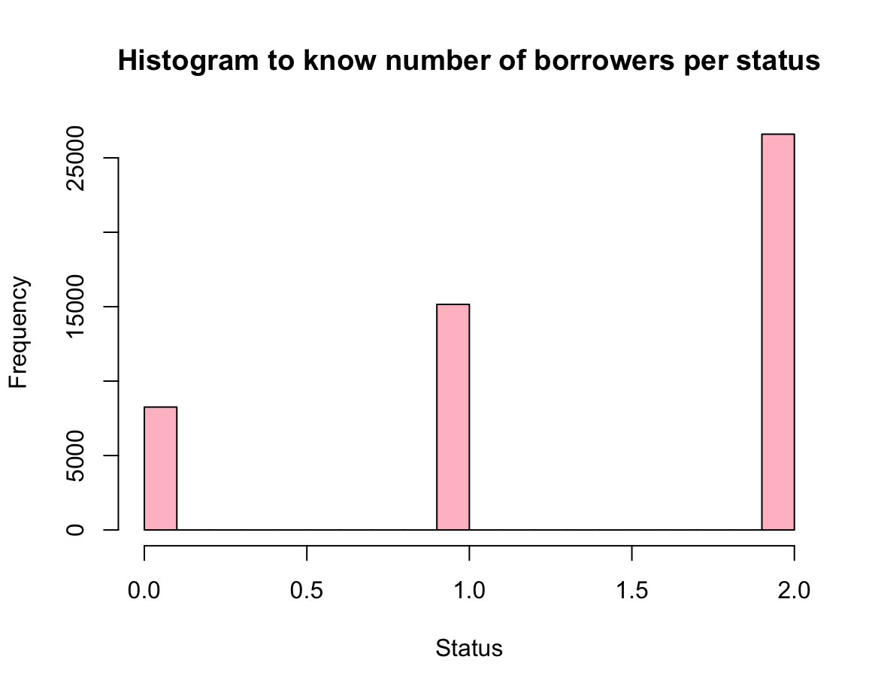

Figure 10 Different type of borrowers.

The histogram in fig 10 the distribution of mortgage borrowers based on their loan status. Here, the xaxis represents the different statuses, while the yaxis indicates the number of borrowers associated with each status. Titled "Histogram to know number of borrowers per status," the graph provides insight into the distribution of borrowers across various loan statuses. The pink color palette adds a visually appealing touch to the representation of borrower statuses.

1. **uer_time**

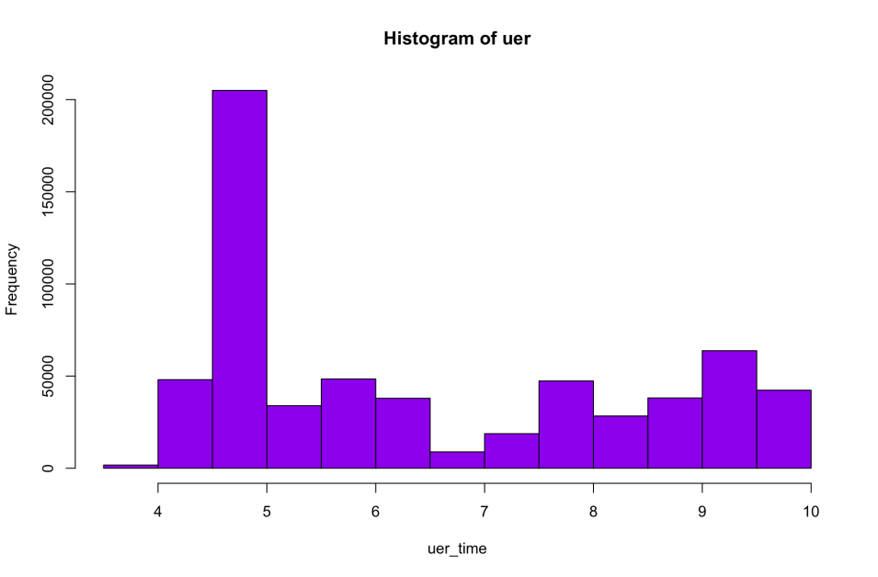

Figure 11 Uer_time count.

The graph in fig 11 shows us the count of unemployment rate customers during the observation time in the dataset.

## Categorical Variables

1. **Histogram for Property type**

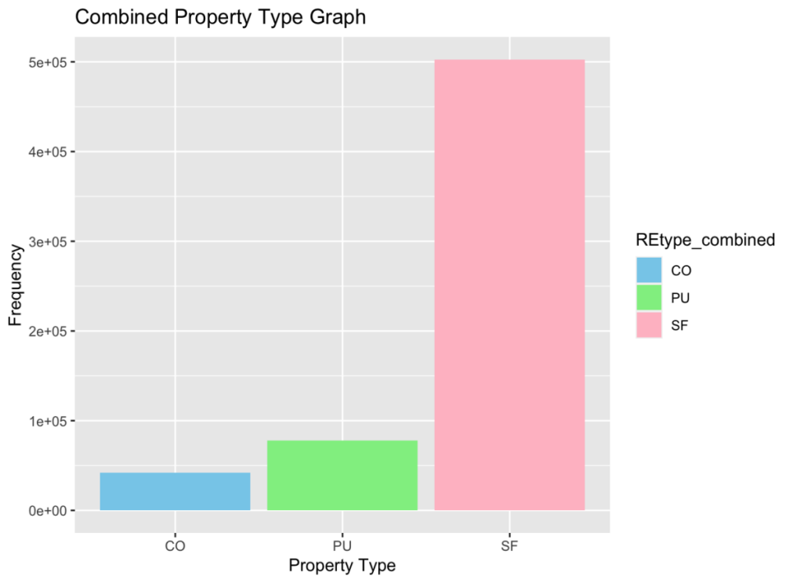

Figure 12 Property Type

The graph in fig 12 shows how many mortgages fall into each of the combined property type categories (CO, PU, and SF).

1. **Count of borrower who are investor**

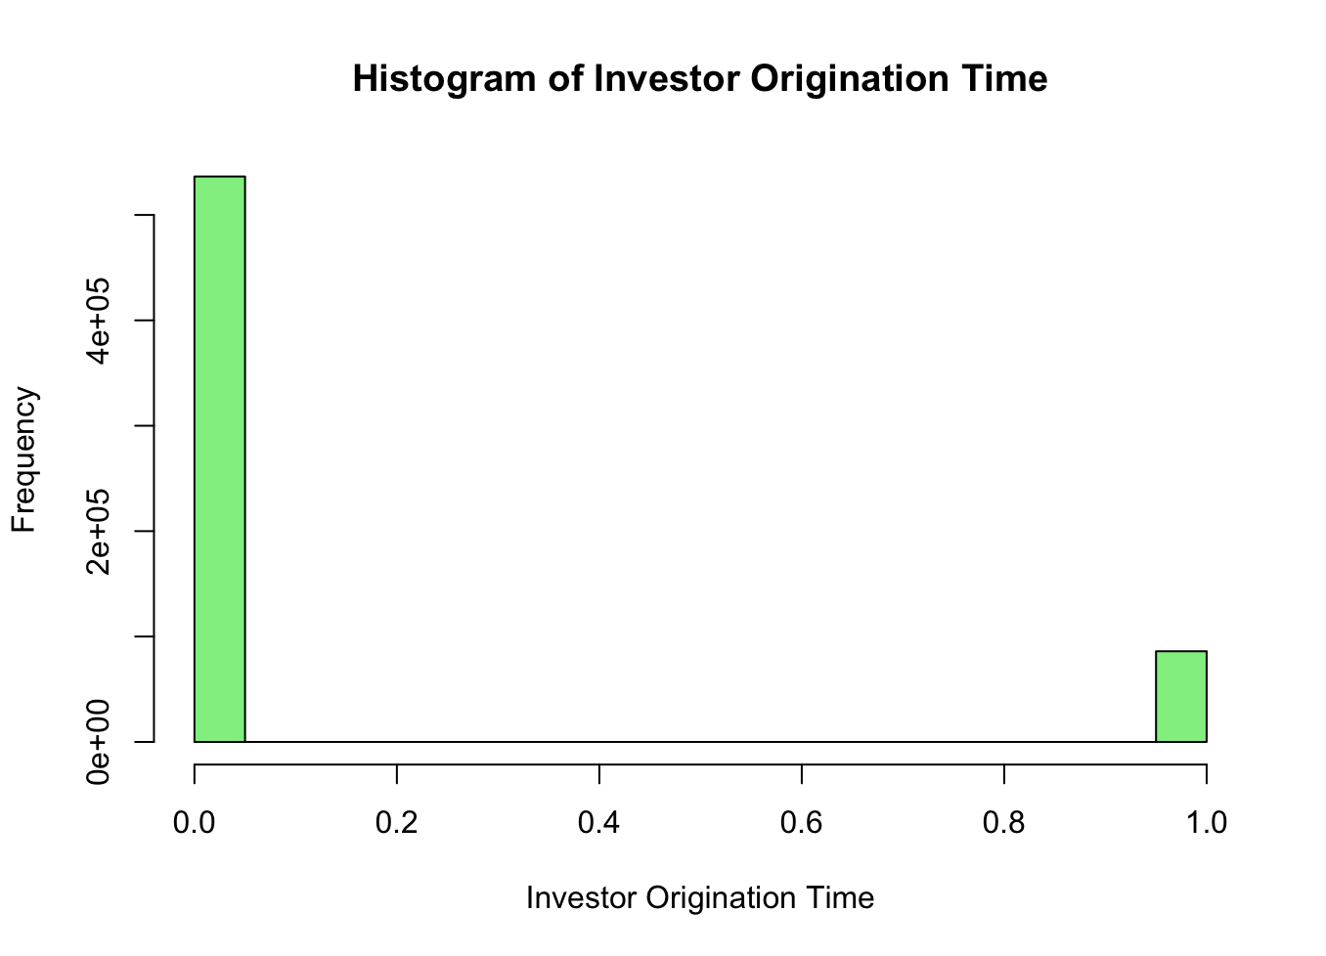

Figure 13 Count of borrower as investor.

There are nearly 86044 investors as borrowers as shown in fig 13.

# Correlation Analysis

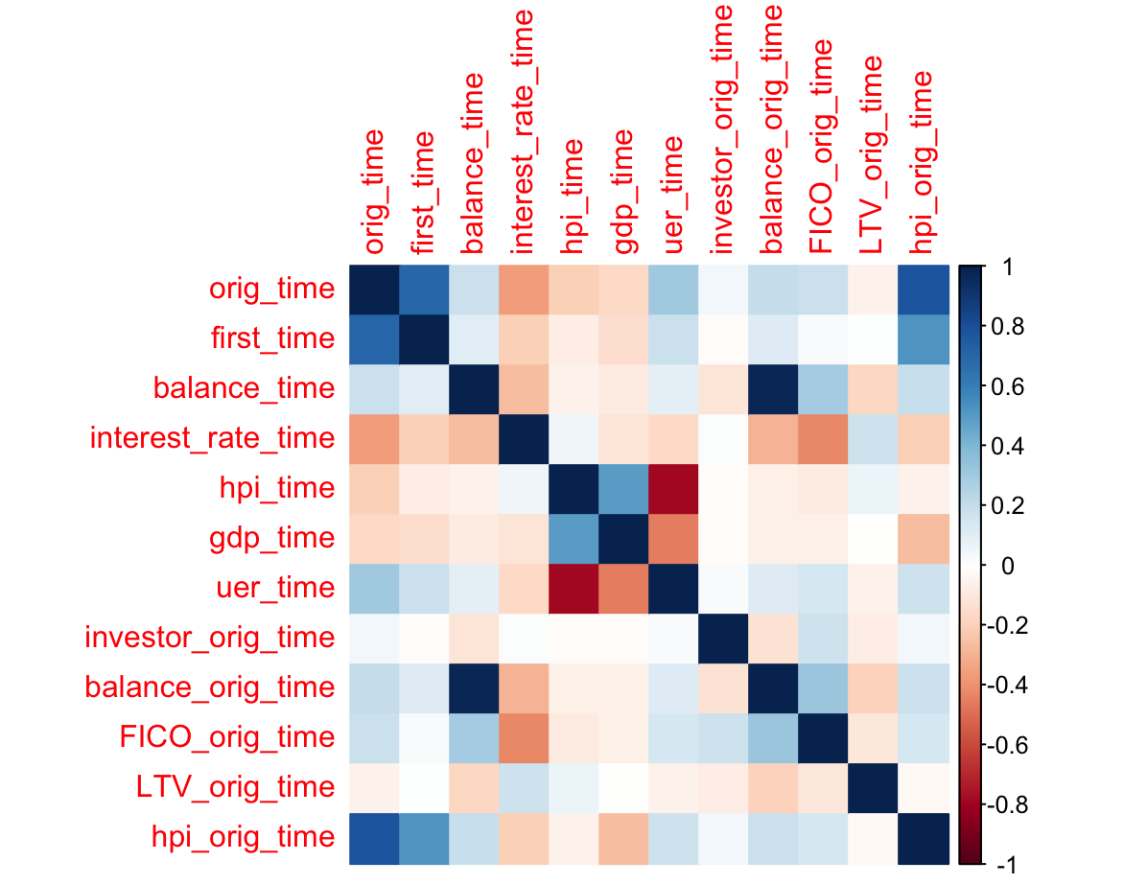

Figure 14 Correlation Matrix

The graph displays the average time spent on various tasks related to loan processing. Notably, tasks like orig_time and first_time take the longest, suggesting initial processing stages require substantial time. However, anomalies such as negative values for tasks like investor_orig_time and FICO_orig_time raise questions about data accuracy or relevance. The absence of data points for GDP_time and hpi_orig_time underscores potential gaps in the dataset, warranting further investigation. Overall, the graph provides insights into time allocation across different stages of loan processing but also highlights areas requiring clarity and validation.

# Data partitioning methods

We're dividing the dataset into three parts:

**Training data:** It's like the core of our learning process, consisting of the first half of the data. Here, the model learns how things work. Its 70% of data having observation with Status_time = 1 and 2

**Validation data:** It's 30% of the data and helps us tweak and improve the model's settings having observation with Status_time = 1 and 2

**Holdout data set:**  It consist of data with status_time = 0

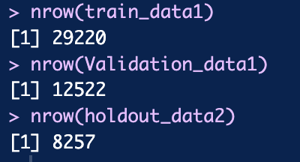

# Classification Models

## Goal 1: Predicting Loan Outcome for Active Borrowers

Our goal is to predict whether each borrower will successfully pay off their loan or default on it. This classification task helps us proactively manage your loan portfolio and minimize potential losses.

### Model Analysis

We begin by focusing on borrowers who currently have active loans, indicated by a status_time of 0 in your dataset. For each borrower, we gather various features such as their loan balance, interest rate, property type, and any other relevant information available.Using this dataset, we built two classification models: Logistic Regression and Classification Tree

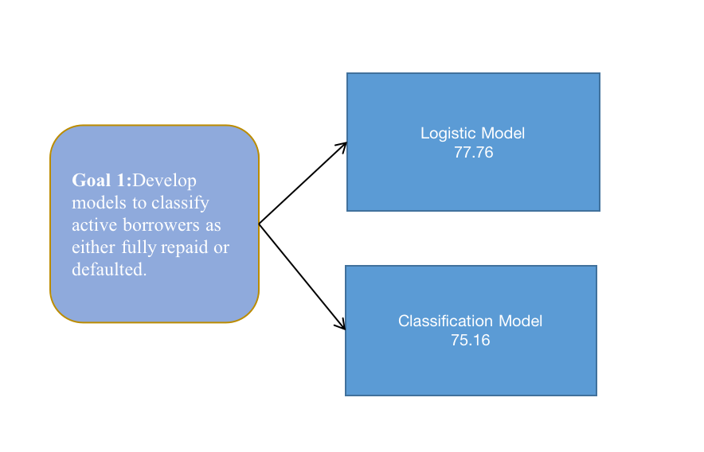

Figure 15 Model Analysis for Goal 1

## Goal 2: Assessing Loan Eligibility for New Customers

Using historical data and insights from past loan applications, you develop a classification model tailored to assessing loan eligibility. This model learns to identify patterns associated with successful loan applicants versus those who may default.

### Model Analysis

When a new customer applies for a loan, the model evaluates their profile against these learned patterns. For goal 2 we have chosen Logistic Regression and Classification Tree

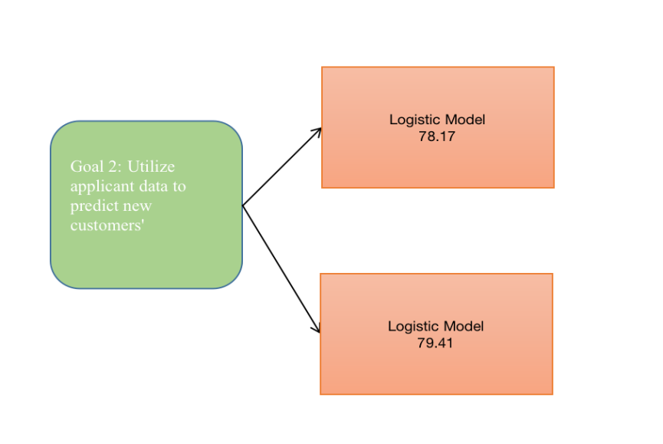

Figure 16 Model Analysis for goal 2.

# Model Selection and Holdout data

## For Goal-1

As logistic Regression has a slightly better accuracy than the tree we would go with the logistic as our selected model and predict the holdout set.

|  |  |
| --- | --- |
| Paid off | Default |
| 6181 | 2076 |

With the model in place, we can now classify each active borrower into one of two categories: "Likely to Pay Off" or "Likely to Default". The total active borrowers in our dataset are 8257 out of which our model predicts that 6181 would be paid off and the rest 2076 would be defaulted and so these borrowers need to be observed and they can be given counselling.

## For Goal-2

Based on this assessment, the model classifies the customer into one of two categories: "Recommended for Loan Approval" or "Not Recommended for Loan Approval"

|  |  |
| --- | --- |
| Recommended for Loan Approval | Not Recommended for Loan |
| 7944 | 263 |

This classification empowers us to make informed decisions, balancing the customer's needs with the bank's risk management strategies. It helps ensure that loans are extended to customers who are likely to honor their financial commitments while mitigating the risk of defaults.

# Combined Analysis

## Model Performance Evaluation:

For predicting loan outcomes for active borrowers, both Logistic Regression and Classification Tree models were employed. While Logistic Regression achieved slightly higher accuracy (76.41%) compared to the Classification Tree (76.03%), the difference is not substantial.

When assessing loan eligibility for new customers, Classification Tree outperformed the Logistic Regression model in terms of accuracy, sensitivity, and specificity. Logistic Regression achieved an accuracy of 78.16% with a sensitivity of 73.32% and specificity of 80.37%, whereas the Classification Tree achieved an accuracy of 79.37% with a sensitivity of 78.18% and specificity of 80.11%.

## Model Selection and Holdout Data:

Given the marginal difference in accuracy and the better performance in sensitivity and specificity, Logistic Regression is chosen as the preferred model for both goals.The holdout data can be used to validate the performance of the selected Logistic Regression model. By applying the model to the holdout set, we can assess its generalization ability and ensure its reliability in real world scenarios.

# Business Recommendations

**Recommendations for Active Borrowers:**

Out of the 8,257 active borrowers, the Logistic Regression model predicts that 6,858 are likely to pay off their loans, while 1,399 are likely to default. These borrowers need closer observation and proactive management.

It is recommended to implement strategies such as targeted communication, financial counseling, or restructuring options for borrowers identified as likely to default. By intervening early, the bank can potentially mitigate losses and improve loan repayment rates.

**Recommendations for Loan Eligibility Assessment:**

The classification model for assessing loan eligibility should be integrated into the loan application process for new customers.

Customers classified as "Recommended for Loan Approval" by the Logistic Regression model can be fasttracked for approval with minimal scrutiny, streamlining the application process and improving customer experience.

Customers classified as "Not Recommended for Loan Approval" should undergo further review or be subject to additional requirements before loan approval. This ensures prudent risk management and reduces the likelihood of defaults.

# Executive Summary

**Nikroshitha A Notani**

**April 24, 2024**

**Business Opportunities**

The primary objective of this project is to assist banks and lending institutions in making informed decisions regarding mortgage portfolio management. By leveraging data analytics, the aim is to mitigate risks associated with mortgage lending, enhance loan performance, and ultimately increase profitability. The overarching goal is to ensure that mortgage lending decisions are intelligent and efficient, promoting financial stability and customer satisfaction.

**Solution**

The project aims to aid banks and lending institutions in optimizing mortgage portfolio management by leveraging data analytics. Through comprehensive data pre processing, exploration, and transformation, key insights into borrower and loan characteristics have been uncovered. Predictor analysis and dimension reduction techniques have streamlined the dataset, facilitating the selection of logistic regression and decision trees as classification models. By partitioning the data and evaluating model performance, the project equips stakeholders with actionable insights to mitigate risks, enhance loan performance, and drive profitability, thereby promoting financial stability and customer satisfaction in the mortgage lending industry.